HANOI UNIVERSITY OF SCIENCE AND TECHNOLOGY

School of Information and communications technology

Software Design Document

Version 1.0

**EcoBikeRental**

Subject: ITSS Software Development

Group 8:

Trần Thị Hằng - 20176748

Dương Thị Huê - 20176772

Đỗ Minh Thông - 20176881

Phạm Nhật Linh – 20184285

*Hanoi, November 2020*

Table of Contents

Table of Contents 1

1 Introduction 4

1.1 Objective 4

1.2 Scope 4

1.3 Glossary 4

1.4 References 5

2 Overall Description 6

2.1 General Overview 6

2.2 Assumptions/Constraints/Risks 7

2.2.1 Assumptions 7

2.2.2 Constraints 7

2.2.3 Risks 7

3 System Architecture and Architecture Design 4

3.1 Architectural Patterns 8

3.2 Interaction Diagrams 8

3.3 Analysis Class Diagrams 13

3.4 Unified Analysis Class Diagram 16

3.5 Security Software Architecture 16

4 Detailed Design 17

4.1 User Interface Design 17

4.1.1 Screen Configuration Standardization 17

4.1.2 Screen Transition Diagrams 18

4.1.3 Screen Specifications 19

4.2 Data Modeling 29

4.2.1 Conceptual Data Modeling 29

4.2.2 Database Design 30

4.3 Non-Database Management System Files 37

4.4 Class Design 37

4.4.1 General Class Diagram 37

4.4.2 Class Diagrams 37

4.4.3 Class Design 38

5 Design Considerations 60

5.1 Goals and Guidelines 60

5.2 Architectural Strategies 60

5.3 Coupling and Cohesion 60

5.4 Design Principles 60

5.5 Design Patterns 60

**List of Figures**

Fig 1. General Use Case Diagram 6

Fig 2. Communication Diagram for Deduct money from card 8

Fig 3. Communication Diagram for Return Bike 9

Fig 4. Communication Diagram for Rent Bike 9

Fig 5. Communication Diagram for Select Dock marker 10

Fig 6. Communication Diagram for View Bike or Station information 10

Fig 7. Sequence Diagram for Deduct money from card 11

Fig 8. Sequence Diagram for Return Bike 11

Fig 9. Sequence Diagram for Rent Bike 12

Fig 10. Sequence Diagram for Select Dock marker 12

Fig 11. Sequence Diagram for View Bike or Station information 13

Fig 12. Analysis Class Diagram for Deduct money from card 13

Fig 13. Analysis Class Diagram for Return Bike 14

Fig 14. Analysis Class Diagram for View Bike or Station information 14

Fig 15. Analysis Class Diagram for Rent Bike 15

Fig 16. Analysis Class Diagram for Select Dock marker 15

Fig 17. Unified Analysis Class Diagram 16

**List of Tables**

No table of figures entries found.

# Introduction

## Objective

This SDD is written for the purpose of giving the audience a clear view about the design of the software. The document’s intended audience is stakeholder and software designer/developer.

## Scope

Product name: **EcoBikeRental Software (Eco-Bike-Rental is how we read)**

Explain:

The software is for users to rent and return bikes automatically. EcoBikeRental is a 24/7 platform-independent system which allows novice users to user without any training. User must have an account to use the system. The software allows user to enter barcode or directly choose bike to rent and choose any bike station to return bike, use credit card for payment, and show detailed information of station and bike.

Application:

Nowadays, the need for using bike is higher than ever. Using bike is not only environmentally friendly, but also a very effective way of exercising. The main drawback of this need is that not everyone has a bike, or has any intention of buying one. How about renting public bike for a relative cheap price? Introduce to our software. EcoBikeRental provides a quick and convenience way to rent bike. It helps to reduce employees, saves money and time, and very convenience. It is very easy to use. With a lot of stations and bikes available, it satisfies the need of bike rental service especially in Eco Park Township.

## Glossary

We assume that the reader of this document has relatively good base knowledge about computer/software in general. Still, the document will be written in general-audience-friendly way that most reader can understand. Scholarly terms, if any, in this document will be briefly explained after it has been used.

## References

Centers for Medicare & Medicaid Services. (n.d.). *System Design Document Template.* Retrieved from Centers for Medicare & Medicaid Services: https://www.cms.gov/Research-Statistics-Data-and-Systems/CMS-Information-Technology/XLC/Downloads/SystemDesignDocument.docx

# Overall Description

## General Overview

About the system, we have some characteristics that make the apps resemble e-commercial website/software: An interface for interacting with user; user request by clicking on the interface and then the request is processed by system controller; we have a database (remote) to store any kind of data; any data-related request or change will be queried in the database; the change in database is then reflected in the UI (user interface). As you can see, there are three main components in the system: the UI, controller and data model. We choose this software to be a desktop application. We choose the three-layer architecture to be our design approach. The design architecture helps to separate different components and better organize the codebase.

Here is general use-case diagram to help you understand the core of our design:

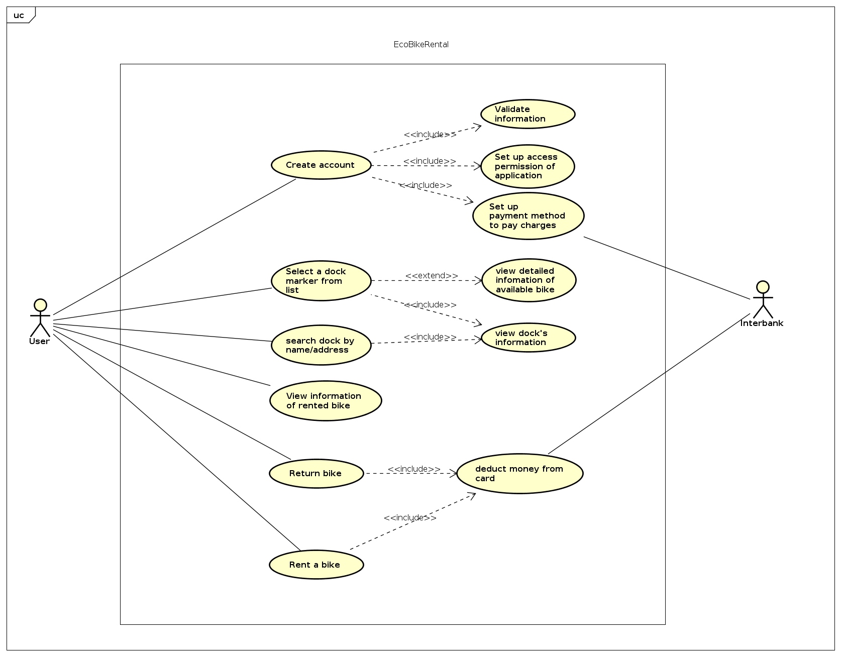

*Fig 1. General Use Case Diagram*

## Assumptions/Constraints/Risks

### Assumptions

User that use the software should have a good connection to the Internet. Also, our software is a desktop application, so the user also must have a laptop/desktop with an OS (we recommended 64 Bit Microsoft Windows 8 or later; macOS 10.13 or later; or any Linux distribution that supports running application) to run the apps. About the system requirement, we would say 2 GB RAM minimum, 8 GB RAM recommended; for storage 2.5 GB and another 1 GB for caches minimum, solid-state drive with at least 5 GB of free space recommended; require latest version of JRE; 1024×768 minimum screen resolution, 1920×1080 is a recommended screen resolution.

### Constraints

* Less than 2GB RAM; JRE version<8; Low storage may cause the software to run incorrectly, or cannot start running at all.
* Implicitly stated, ideally, the response time for any tasks, with a moderate load, within the system is 1 second. But in case of peak load, a response time in the interval of 2 seconds is admissible.
* Weak or no internet connection may cause the software to run improperly.

### Risks

* The database may have fault data if the user closes the application when not returning bike.

# System Architecture and Architecture Design

Architecture Design steps:

1. Find out software components -> use cases
2. Find out Interaction between use cases
3. Find out Relationship between use cases
4. Draw UML Diagram includes: interaction diagram and analysis class diagram

## Architectural Patterns

In our project, we use 3-tier architectural pattern. There are many benefits of separating an application into tiers and the most important thing is it allows us to update a specific part of an application independently of the other parts

## Interaction Diagrams

**3.2.1. Communication Diagrams**

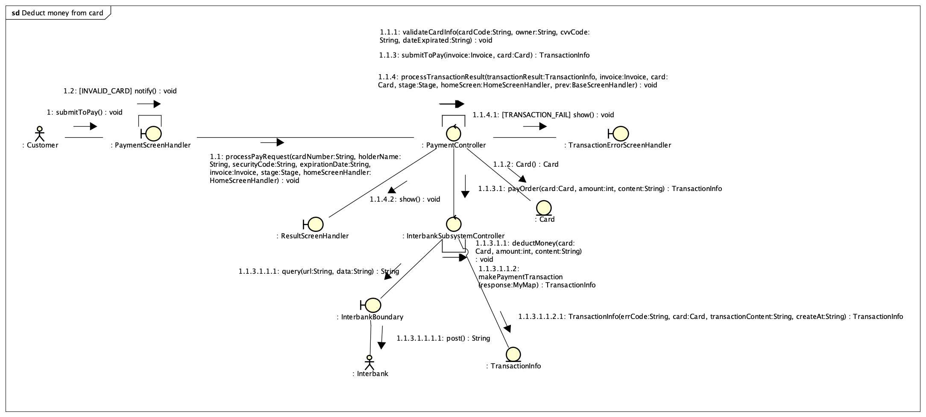

*Fig 2. Communication Diagram for Deduct money from card*

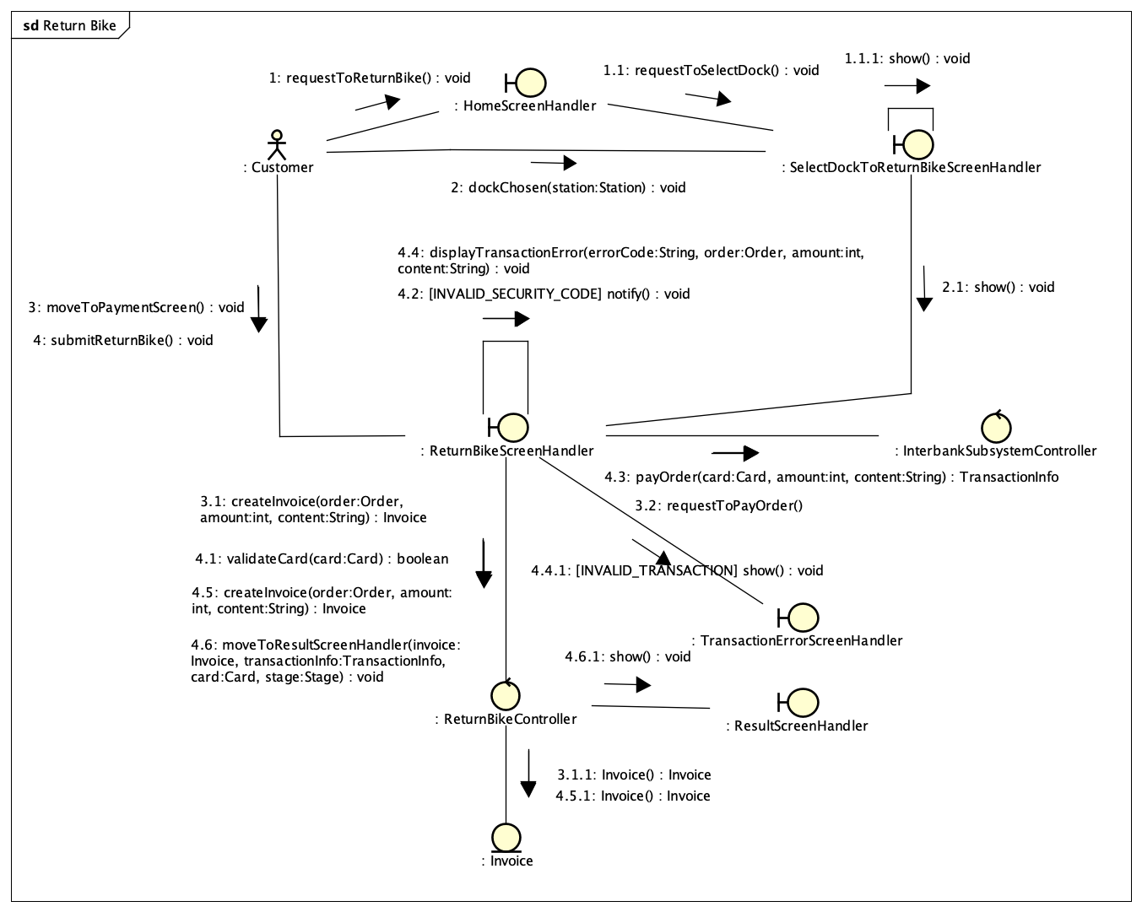

*Fig 3. Communication Diagram for Return Bike*

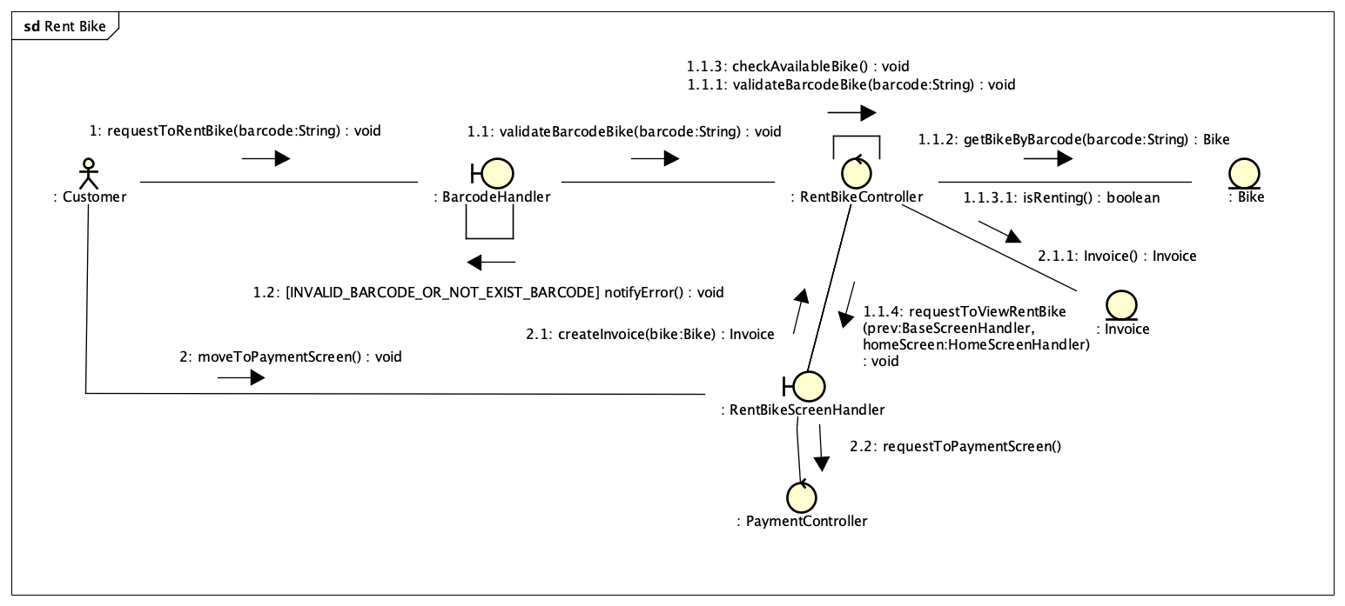

*Fig 4. Communication Diagram for Rent Bike*

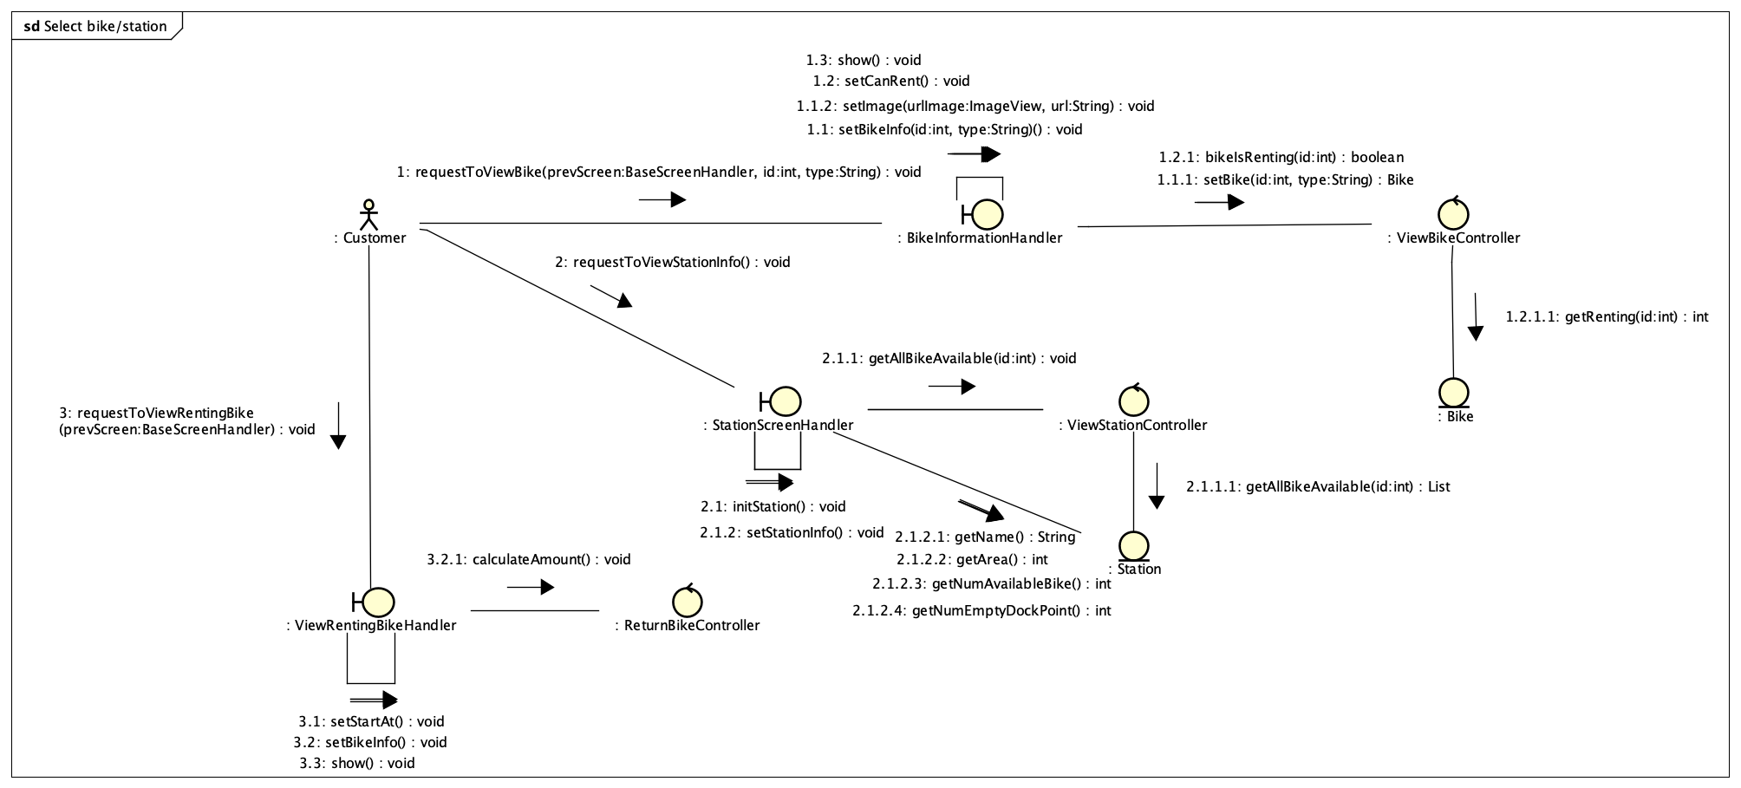

*Fig 5. Communication Diagram for View Bike or Station information*

* + 1. **Sequence Diagrams**

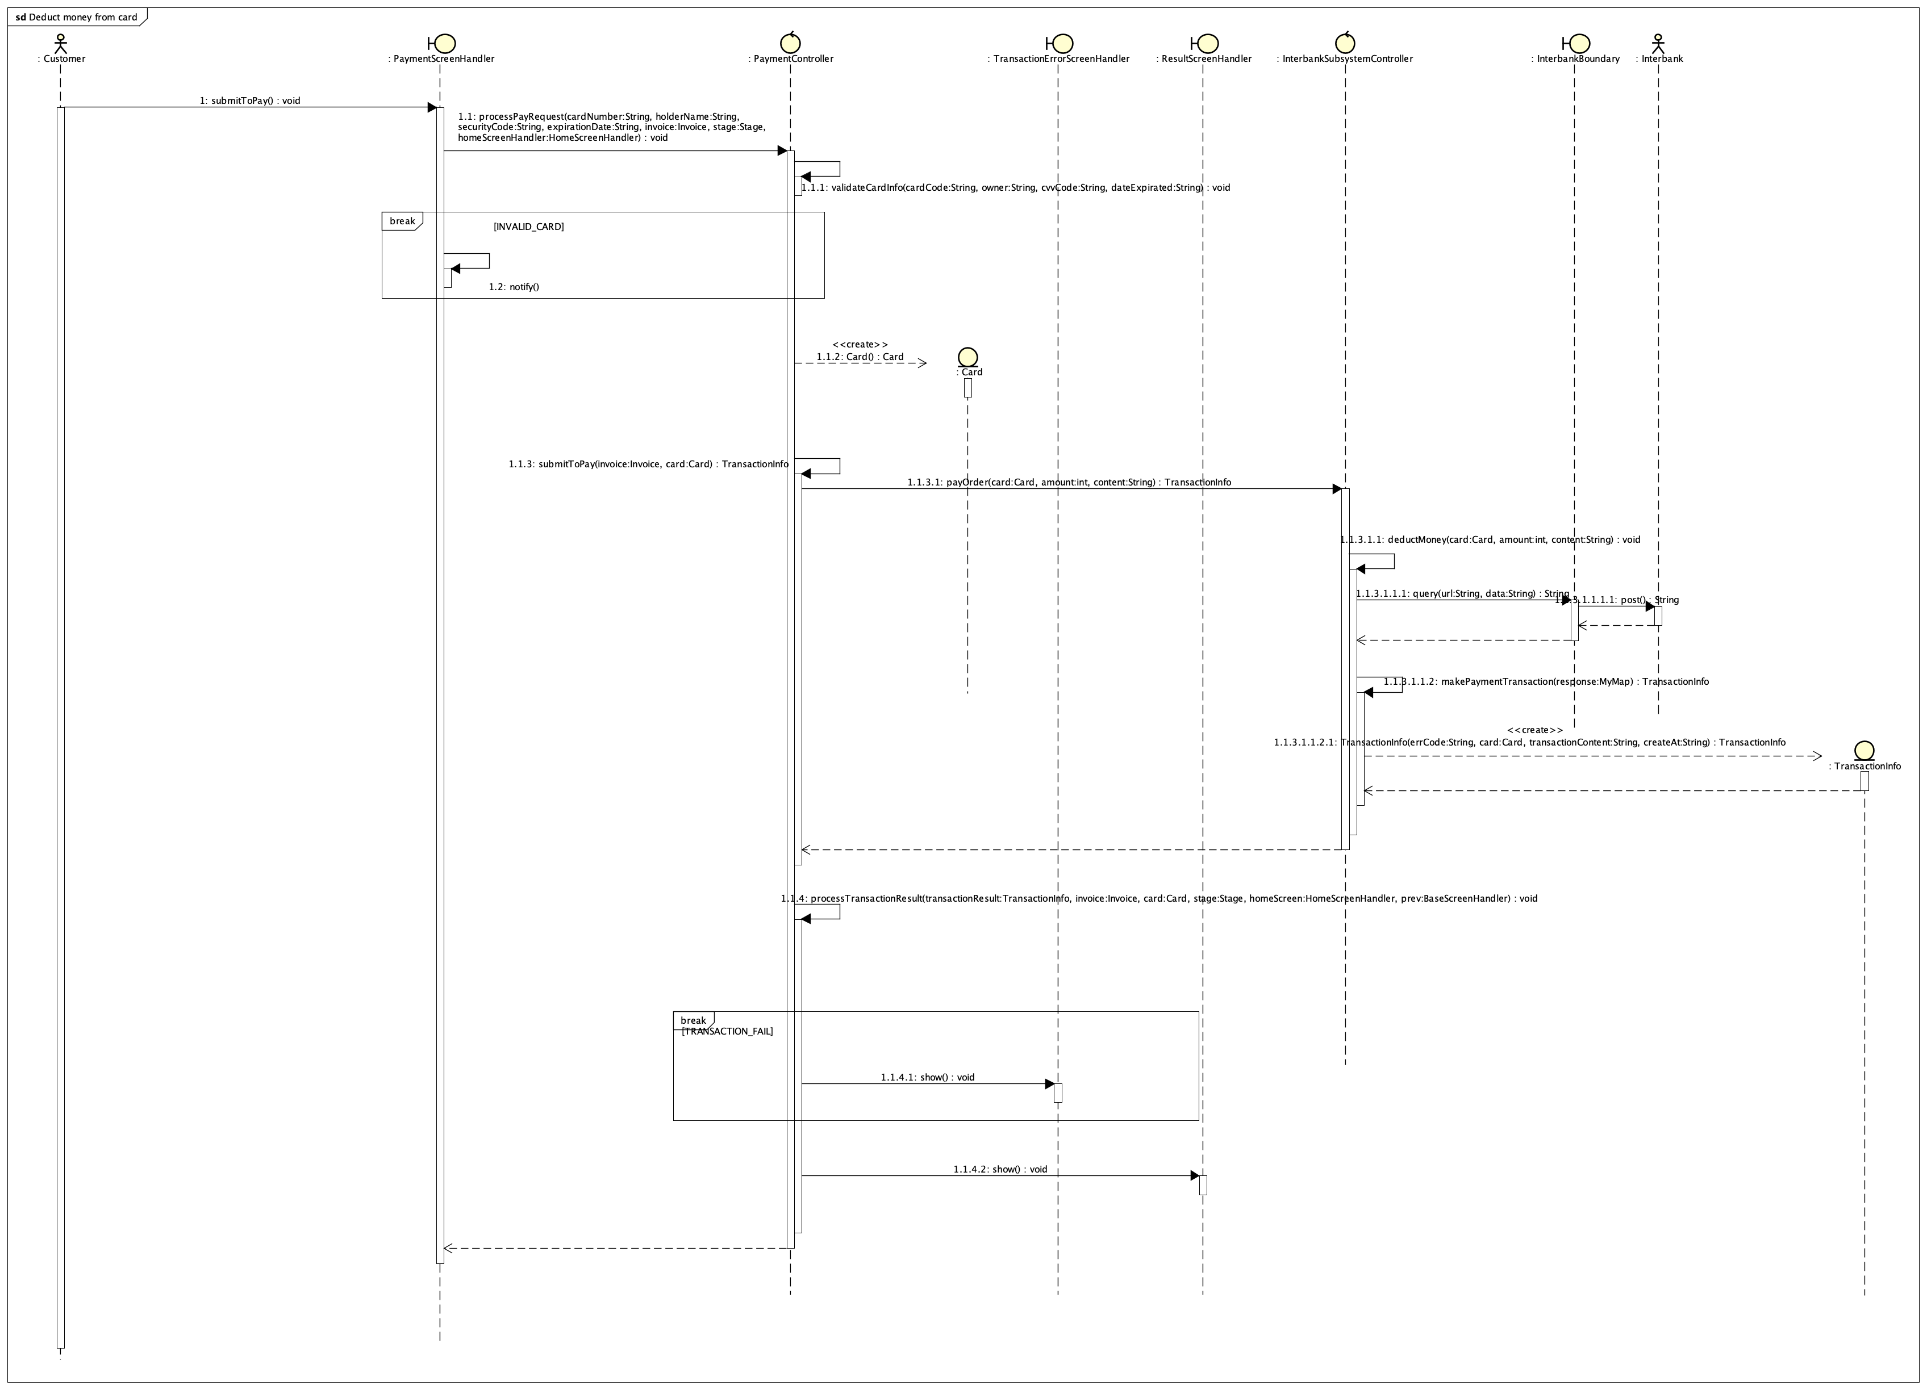

*Fig 6. Sequence Diagram for Deduct money from card*

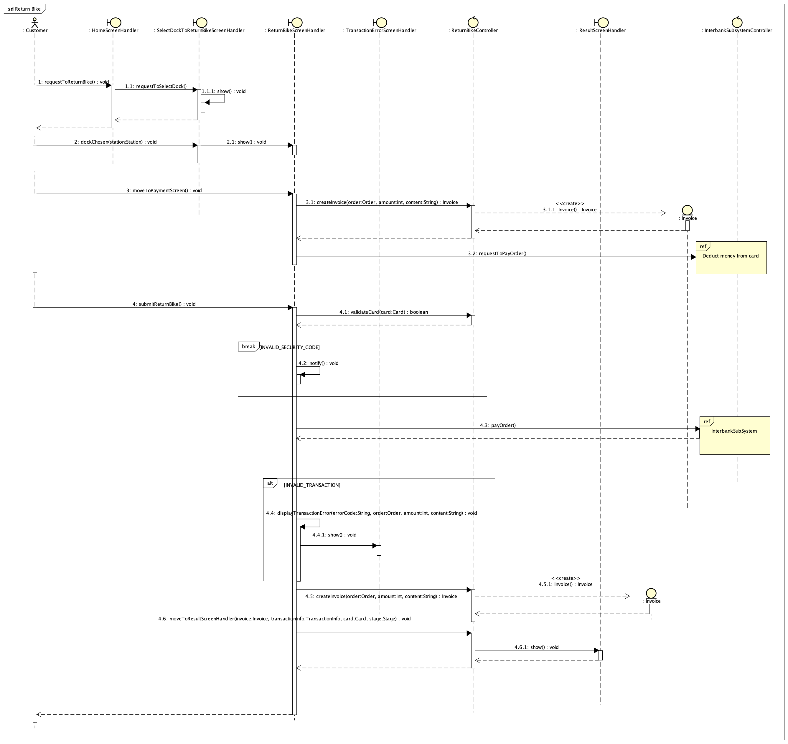

*Fig 7. Sequence Diagram for Return bike*

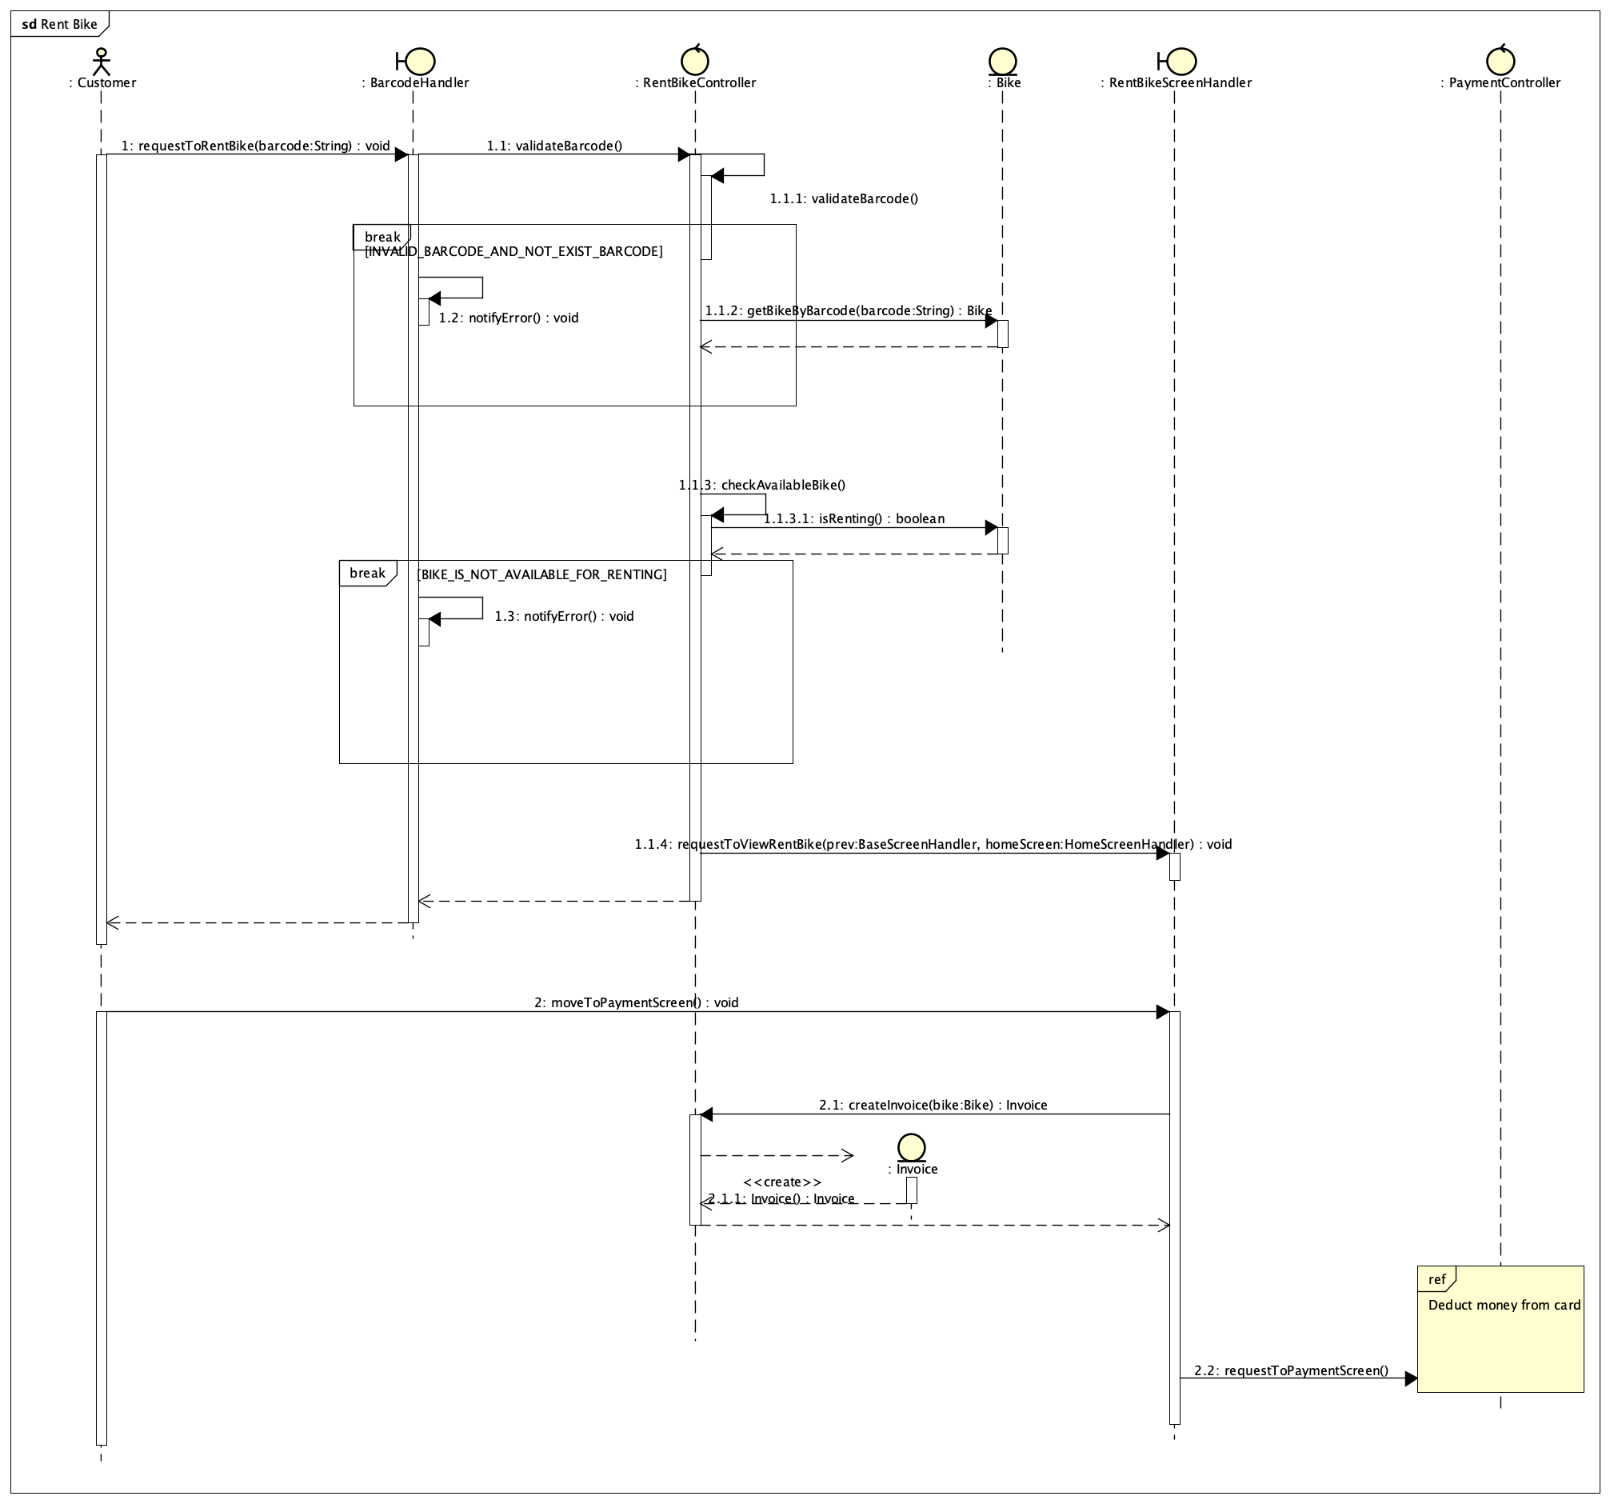

*Fig 8. Sequence Diagram for Rent bike*

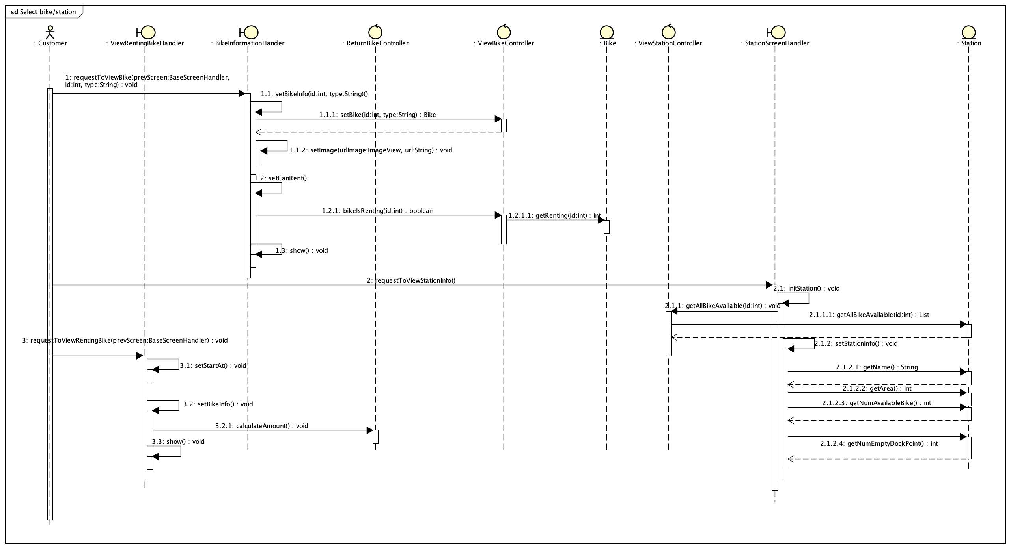

*Fig 9. Sequence Diagram for View Bike or Station information*

## Analysis Class Diagrams

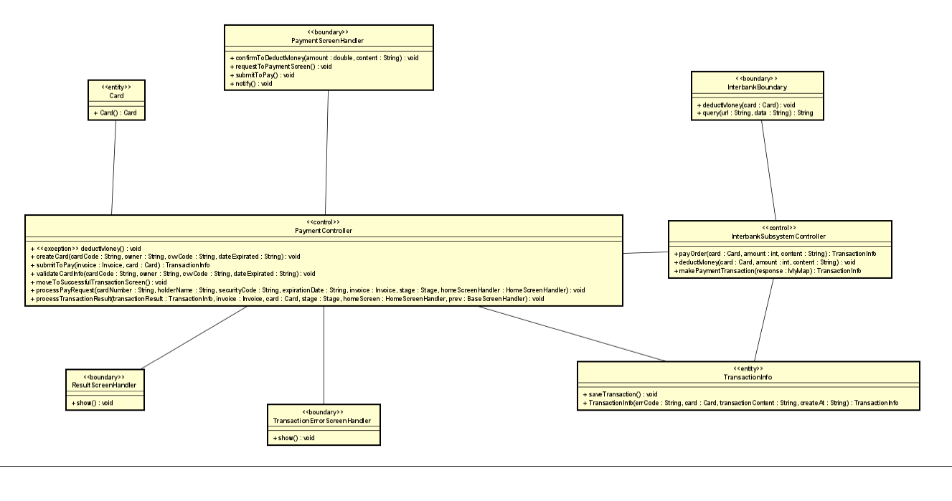

*Fig 10. Analysis Class Diagram for Deduct money from card*

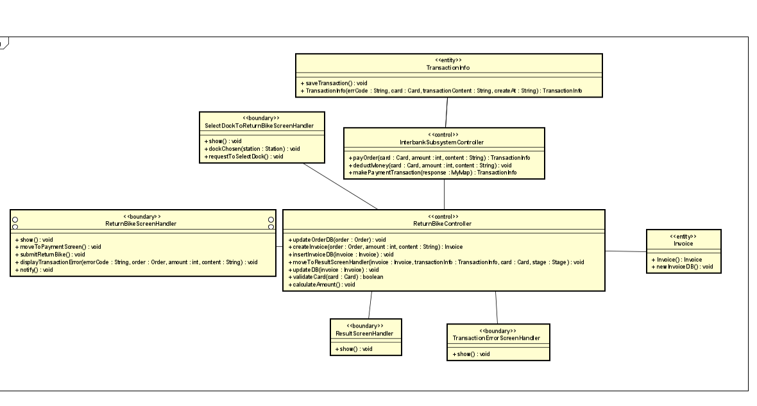

*Fig 11. Analysis Class Diagram for Return bike*

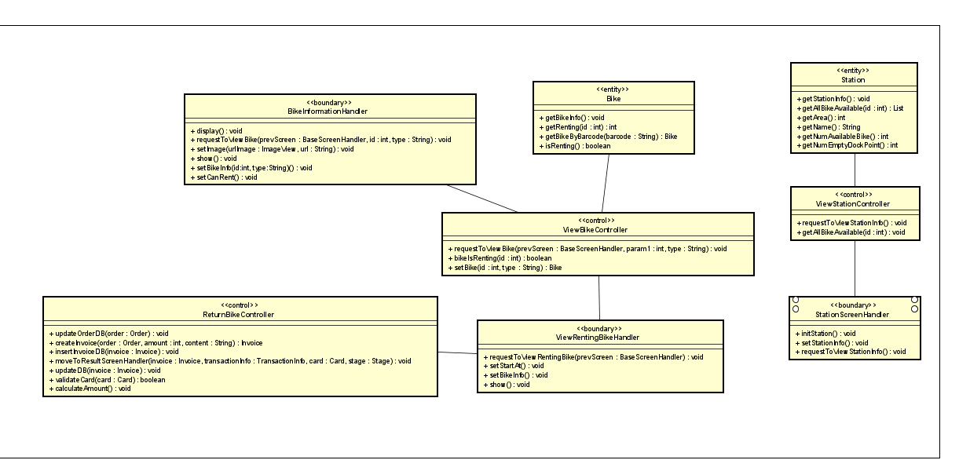

*Fig 12. Analysis Class Diagram for View Bike or Station information*

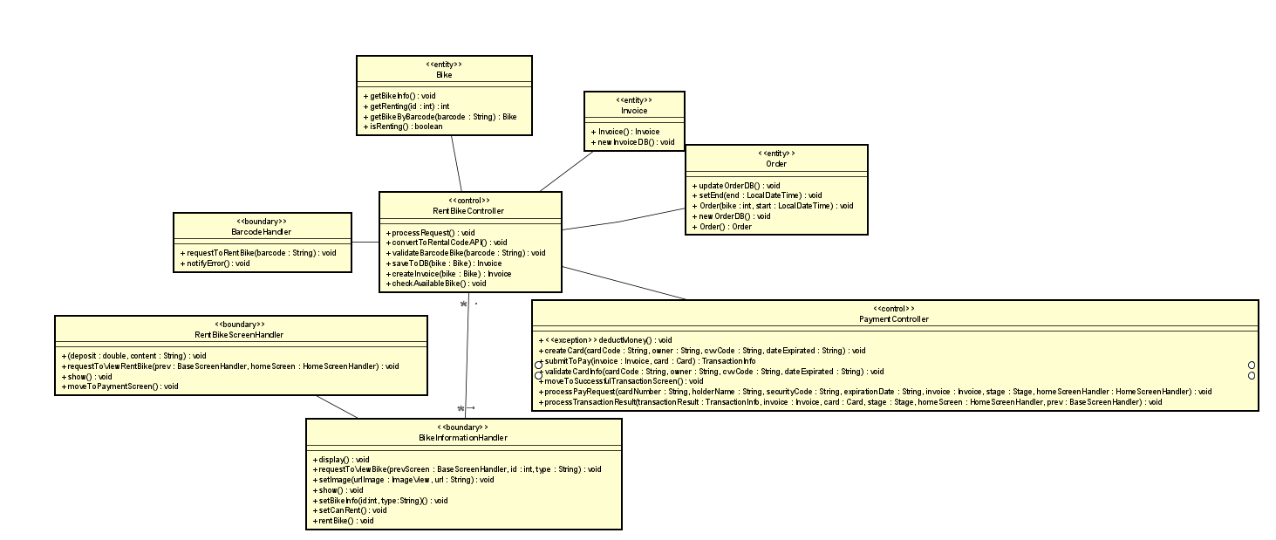

*Fig 13. Analysis Class Diagram for Rent bike*

## Unified Analysis Class Diagram

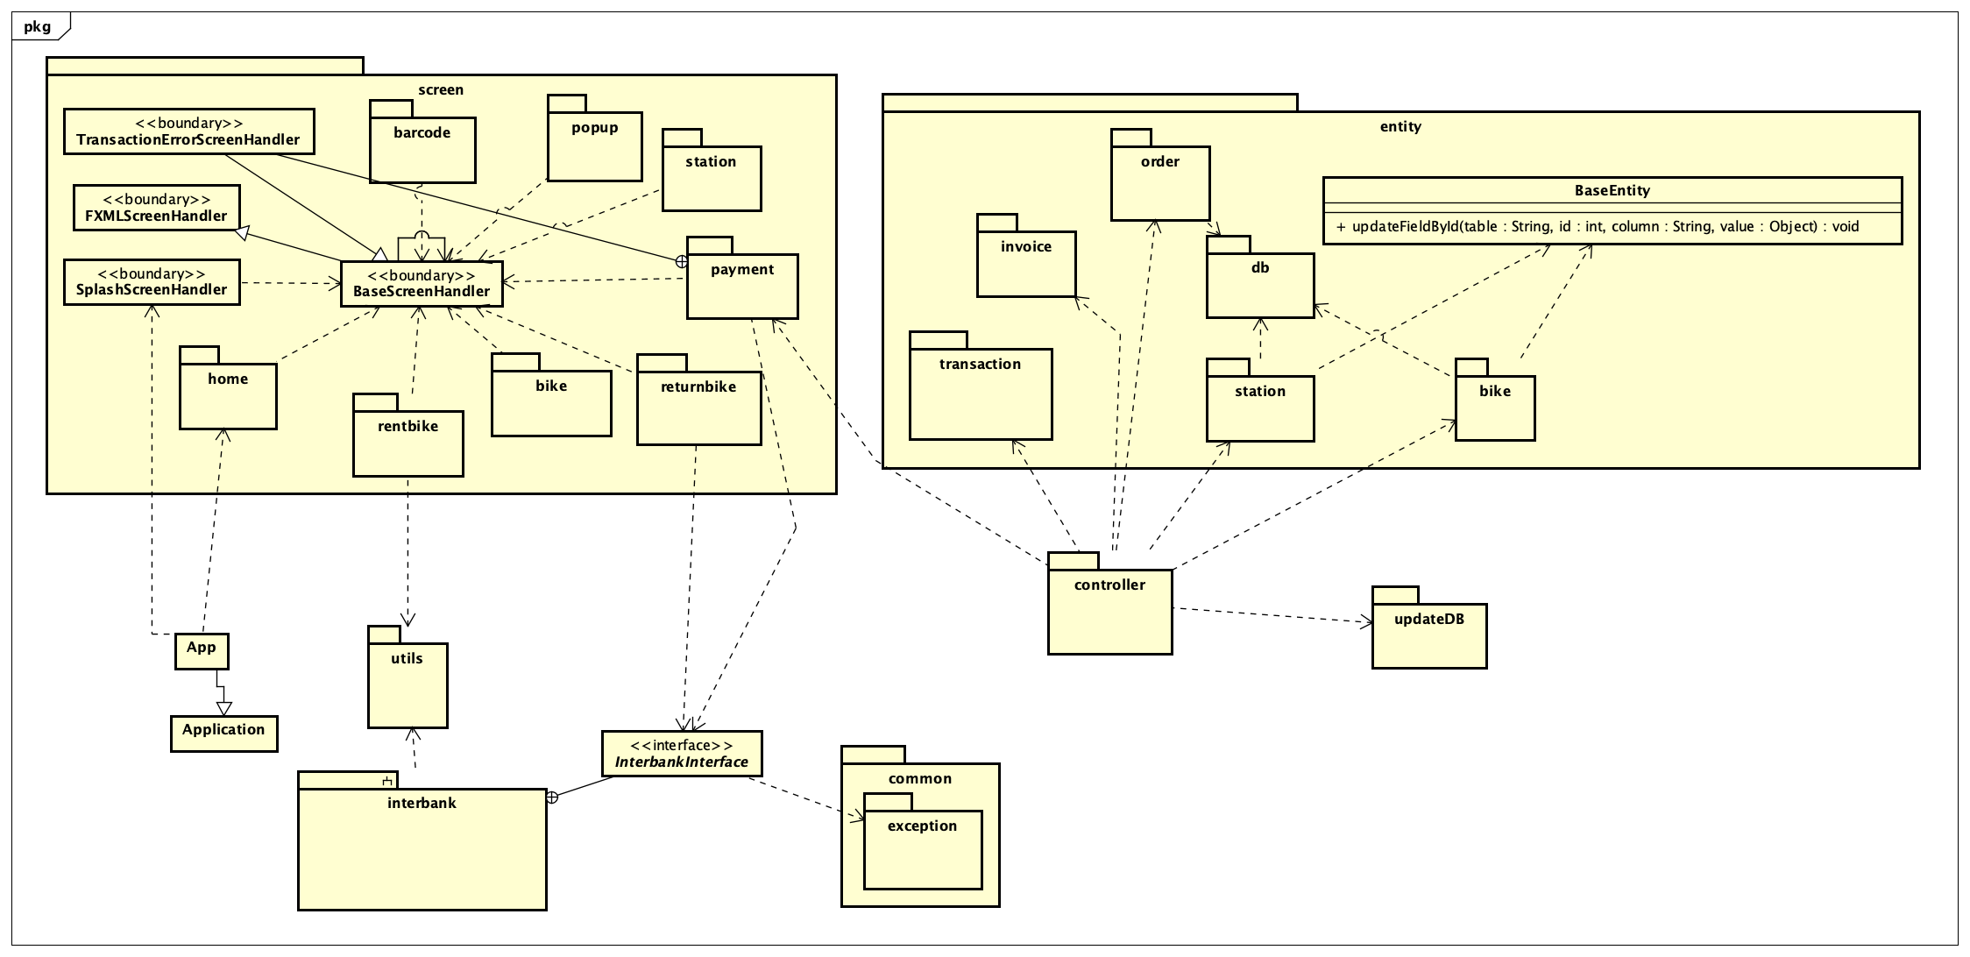

*Fig 14. Unified Analysis Class Diagram*

## Security Software Architecture

In this project, we will not consider features such as user authentication (e.g., sign up, sign in, sign out), but we focus on features related to bike renting and returning.

# Detailed Design

## User Interface Design

### Screen Configuration Standardization

**Display**

Number of colors supported: 16,777,216 colors

Resolution: 1366 × 768 pixels

**Screen**

- Location of standard buttons: At the bottom (vertically) and in the middle

(horizontally) of the frame

- Location of the messages: Starting from the top vertically and in the right horizontally of the frame down to the bottom.

- Display of the screen title: The title is located at the top of the frame in the middle.

- Consistency in expression of alphanumeric numbers: comma for separator of thousand while strings only consist of characters, digits, commas, dots, spaces, underscores, and hyphen symbol.

**Control**

- Size of the text: medium size (mostly 24px). Font: Arial. Color: # 201C1C

- Input check process: Should check if it is empty or not. Next, check if the input is in the correct format or not

- Sequence of moving the focus: There will be no stack frames. Each screen will be separated. However, the manual is considered a popup message, as the main screen cannot be operated while the manual screen is shown. After the opening screen, the app will start with splash screen, and then the first screen (home screen) will appear.

- Sequences of the system screens:

1. Splash screen (first screen)

2. Home screen

3. View Bike information screen – view information of a bike before renting

4. View Renting Bike information screen – view information of a renting bike

5. View Dock information screen – view information of a dock

6. View distance screen – view distance from user’s location to selected dock

7. Payment screen – fill payment information

8. Transaction Error screen – display detailed error of a transaction

9. Return Bike screen – display information to return a bike

10. Select Dock to return Bike screen – display list of docks to return a bike

11. Rent Bike screen – display detailed information for renting a bike

12. Invoice screen – display detailed invoice

13. Enter barcode screen – display a text area for entering barcode to rent bike

**Direct input from the keyboard**

There will be no shortcuts. There are back buttons to move back to the previous screen.

There is a Home button located at the top right of screen to go to Home screen.

Also, there are a close button “X” to close the screen, a resize button to resize screen and a minimize button “ _ “ to shrinks the window and places it on the taskbar while leaving the software running located at the title bar to the right.

**Error**

A message will be given to notify the users what is the problem.

### Screen Transition Diagrams

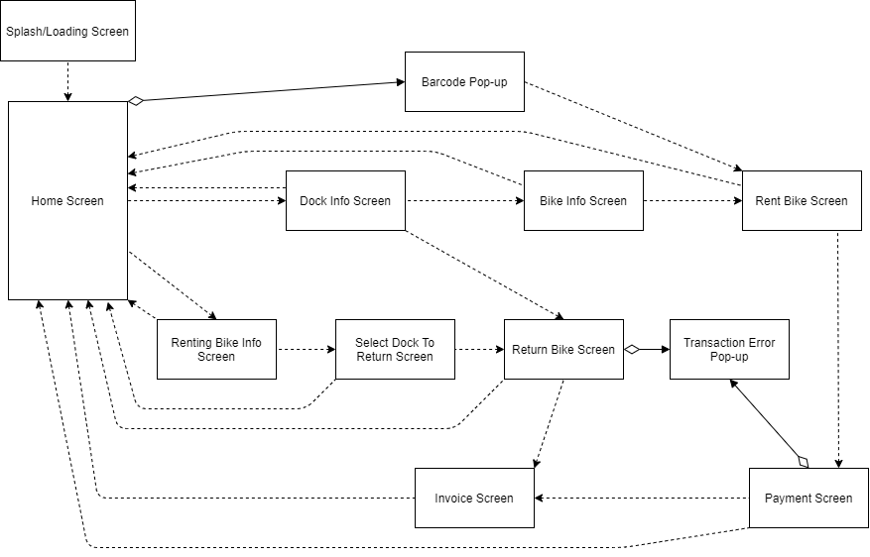

### **Screen Specifications**

***4.1.3.1. Return bike screen***

Screen specification

|  |  |  |  |  |  |
| --- | --- | --- | --- | --- | --- |
| EcoBikeRental Software | | Date of creation | Approved by | Reviewed by | Person in charge |
| Screen specification | Return Bike screen | 7/11/2020 |  |  | Trần Thị Hằng |
|  | | Control | Operation | Function | |
| Area for displaying Bike information | Initial | Display detail information of renting bike | |
| Area for displaying Card information | Initial | Display detail information of Card which will be used for payment | |
| Edit button | Click | Display the Payment Screen | |
| Cancel button | Click | Display Home Screen | |
| Submit button | Click | Display Invoice Screen/Transaction Error Screen | |

Defining the field attributes

|  |  |  |  |  |
| --- | --- | --- | --- | --- |
| Screen name | Return bike screen |  |  |  |
| Item name | Number of digits (bytes) | Type | Field attribute | Remarks |
| Number Plate | 10 | String | Black | Left justified |
| Barcode | 6 | String | Black | Left justified |
| Type | 20 | String | Black | Left justified |
| Battery Percentage | 3 | Numeral | Black | Left justified |
| Remaining time | 2 | Numeral | Black | Left justified |
| Deposit | 10 | Numeral | Black | Left justified |
| Rented time | 5 | Numeral | Black | Left justified |
| Total | 20 | Numeral | Black | Left justified |
| Card holder | 50 | String | Black | Left justified |
| Card number | 20 | Numeral | Black | Left justified |
| Expiration Date | 10 | String | Black | Left justified |
| Security Code | 10 | Numeral | Black | Left justified |

***4.1.3.2. Transaction Error Screen***

Screen specification

|  |  |  |  |  |  |
| --- | --- | --- | --- | --- | --- |
| EcoBikeRental Software | | Date of creation | Approved by | Reviewed by | Person in charge |
| Screen specification | Transaction Error Screen | 7/11/2020 |  |  | Trần Thị Hằng |
|  | | Control | Operation | Function | |
| Change Card Information button | Click | Display Payment Screen | |
| Area for display error | initial | Display error of transaction | |

***4.1.3.3. View Bike Information Screen***

Screen specification

|  |  |  |  |  |  |
| --- | --- | --- | --- | --- | --- |
| EcobikeRental Software | | Date of creation | Approved by | Reviewed by | Persion in charge |
| Screen specification | View bike information screen | 07/11/2020 |  |  | Dương Thị Huê |
|  | | Control | Operation | Function | |
| Area for  displaying the number plate | Initial | Display the number plate | |
| Area for display image of bike | Initial | Display image | |
| Area for display barcode | initial | Display the barcode | |
| Area for display remaining time | initial | Display remaining time of bike if it is electric bike | |
| Area for display battery percentage | initial | Display battery percentage of bike if it is electric bike | |
| Area for display deposit | initial | Display deposit | |
| Area coefficient price | initial | Display coefficient price to calculate amount | |
| Cancel button | Click | Back to station information screen | |
| Rent button | Click | Move to payment screen | |
| Home icon | Click | Back to home | |

Defining the field attributes

|  |  |  |  |  |
| --- | --- | --- | --- | --- |
| Screen name | View bike information screen |  |  |  |
| Item name | Number of digits (bytes) | Type | Field attribute | Remarks |
| Number plate | 8 | Numeral | Black | Left-justified |
| Barcode | 6 | Numeral | Black | Left justified |
| Type | 100 | Text | Black | Left-justified |
| Remaining time | 50 | Text | Black | Left-justified |
| Battery percentage | 4 | Text | Black | Left-justified |
| Deposit | 6 | Number | Black | Left-justified |
| Coefficient price | 3 | Number | Black | Left-justified |

***4.1.3.4. View Station Information Screen***

Screen specification

|  |  |  |  |  |  |
| --- | --- | --- | --- | --- | --- |
| EcobikeRental Software | | Date of creation | Approved by | Reviewed by | Persion in charge |
| Screen specification | View station information screen | 07/11/2020 |  |  | Dương Thị Huê |
|  | | Control | Operation | Function | |
| Area for  displaying the  Dock ‘s name | Initial | Display the name of dock | |
| Area for display dock ‘s address | Initial | Display dock ‘s address | |
| Area for display dock ‘s area | initial | Display the area of the dock | |
| Area for display number available bike | initial | Display remaining number available bike | |
| Area for display the number of empty docks | initial | Display number empty docks | |
| Area for walking time | initial | Display walking time from current user location to dock | |
| Area for display list available bike and its information | initial | Display list available bike in the dock and its information | |
| Home icon | Click | Back to home | |
| Rent button | Click | Move to payment screen | |

Defining the field attributes

|  |  |  |  |  |
| --- | --- | --- | --- | --- |
| Screen name | View bike information screen |  | | |
| Item name | Number of digits (bytes) | Type | Field attribute | Remarks |
| Number plate | 8 | Numeral | Black | Left-justified |
| Barcode | 6 | Numeral | Black | Left justified |
| Type | 100 | Text | Black | Left-justified |

***4.1.3.5. View Renting Bike Screen***

Screen specification

|  |  |  |  |  |  |
| --- | --- | --- | --- | --- | --- |
| EcobikeRental Software | | Date of creation | Approved by | Reviewed by | Persion in charge |
| Screen specification | View renting bike information screen | 07/11/2020 |  |  | Dương Thị Huê |
|  | | Control | Operation | Function | |
| Area for  displaying the bike information | Initial | Display bike information | |
| Area for display  Renting time | initial | Display the renting time | |
| Area for display amount up to now | initial | Display amount to be paid up to now | |
|  | | Area for home icon | click | Back to home | |
| Area for display deposit | initial | Display deposit | |
| Area coefficient price | initial | Display coefficient price to calculate amout | |
| Area for display type | inititial | Display type of bike | |
| Pause icon | click | Stop counting clock | |
| Play icon | Click | Continue counting clock | |

Defining the field “Renting time”attributes

|  |  |  |  |  |
| --- | --- | --- | --- | --- |
| Screen name | View bike information screen |  |  |  |
| Item name | Number of digits (bytes) | Type | Field attribute | Remarks |
| Amount up to now | 8 | Numeral | red | Left-justified |
| Retal time | 8 | Hh:mm:ss | black | Left-justified |

***4.1.3.6. Home Screen***

Screen specification

|  |  |  |  |  |  |
| --- | --- | --- | --- | --- | --- |
| EcobikeRental Software | | Date of creation | Approved by | Reviewed by | Persion in charge |
| Screen specification | Home screen | 07/11/2020 |  |  | Đỗ Minh Thông |
|  | | Control | Operation | Function | |
| Area for  displaying the list of docks | Initial | Display list of docks | |
| View button | Click | Move to view station information screen | |
|  | | Distance button | Click | View distance popup | |
| Home icon | click | Reload home screen | |
| Rent bike button | click | Enter barcode and move to rent bike screen | |
| View renting bike button | Click | Move to view renting bike screen | |
| Return bike button | Click | Move to return bike screen | |
| Area for search | Type | Filter all dock then display | |

Defining the field “Station information” attributes

|  |  |  |  |  |
| --- | --- | --- | --- | --- |
| Screen name | View bike information screen |  |  |  |
| Item name | Number of digits (bytes) | Type | Field attribute | Remarks |
| Station name | 50 | Text | Black | Left-justified |
| Address | 50 | Text | Black | Left-justified |
| Available bike | 11 | Number | Black | Left-justified |
| Empty dock point | 11 | Number | Black | Left-justified |

***4.1.3.7. Splash Screen***

Screen specification

|  |  |  |  |  |  |
| --- | --- | --- | --- | --- | --- |
| EcobikeRental Software | | Date of creation | Approved by | Reviewed by | Persion in charge |
| Screen specification | Splash screen | 07/11/2020 |  |  | Đỗ Minh Thông |
|  | | Control | Operation | Function | |
| Area for  displaying the loading screen | Initial | Display loading screen | |

***4.1.3.8. View Distance Popup Screen***  
Screen specification

|  |  |  |  |  |  |
| --- | --- | --- | --- | --- | --- |
| EcobikeRental Software | | Date of creation | Approved by | Reviewed by | Persion in charge |
| Screen specification | View distance popup screen | 07/11/2020 |  |  | Đỗ Minh Thông |
|  | | Control | Operation | Function | |
| Area for  displaying the station information and walking time estimate | Initial | Display station information and walking time estimate | |
| OK button | Click | Move to home screen | |

Defining the field attributes

|  |  |  |  |  |
| --- | --- | --- | --- | --- |
| Screen name | View bike information screen |  |  |  |
| Item name | Number of digits (bytes) | Type | Field attribute | Remarks |
| Station information | 256 | Text | Black | Left-justified |
| Distance | 50 | String | Black | Left-justified |
| Estimated time | 50 | String | Black | Left-justified |

***4.1.3.9 Invoice screen***

Screen specification

|  |  |  |  |  |  |
| --- | --- | --- | --- | --- | --- |
| EcobikeRental Software | | Date of creation | Approved by | Reviewed by | Persion in charge |
| Screen specification | Invoice Screen | 07/11/2020 |  |  | Trần Thị Hằng |
|  | | Control | Operation | Function | |
| Area for  displaying transaction result | Initial | Display transaction result | |
| Area for display  username | initial | Display the user name | |
| Area for display transaction content | initial | Display transaction content | |
| Back to home button | click | Back to home | |
| Area for display amount | initial | Display amount of invoice | |
| Area for payment method | initial | Display payment method | |

Defining the field “Renting time”attributes

|  |  |  |  |  |
| --- | --- | --- | --- | --- |
| Screen name | View bike information screen |  |  |  |
| Item name | Number of digits (bytes) | Type | Field attribute | Remarks |
| username | 50 | String | black | Left-justified |
| Transaction content | 50 | String | black | Left-justified |
| amount | 11 | String | black | Left-justified |

***4.1.3.10 Select dock to return***

Screen specification

|  |  |  |  |  |  |
| --- | --- | --- | --- | --- | --- |
| EcobikeRental Software | | Date of creation | Approved by | Reviewed by | Persion in charge |
| Screen specification | Select dock to return screen | 07/11/2020 |  |  | Trần Thị Hằng |
|  | | Control | Operation | Function | |
| Area for  displaying the list of docks | Initial | Display list of docks | |
| Reuturn button | Click | Move to return bike screen | |
| Home icon | click | Reload home screen | |
| Area for display dock’s infomation | Initial | Display dock ‘s information | |

***4.1.3.11 Rent bike screen***

Screen specification

|  |  |  |  |  |  |
| --- | --- | --- | --- | --- | --- |
| EcobikeRental Software | | Date of creation | Approved by | Reviewed by | Persion in charge |
| Screen specification | Rent bike screen | 07/11/2020 |  |  | PhạmNhật Linh |
|  | | Control | Operation | Function | |
| Area for  displaying bike information | Initial | Display bike information (like view bike screen) | |
| Rent button | Click | Move to payment screen | |
| Home icon | click | Reload home screen | |
| Cancel button | Click | Back to previous screen | |
| Area for display amount | Intitial | Deposit amount | |

***4.1.3.12 Barcode screen***

Screen specification

|  |  |  |  |  |  |
| --- | --- | --- | --- | --- | --- |
| EcobikeRental Software | | Date of creation | Approved by | Reviewed by | Persion in charge |
| Screen specification | Barcode screen | 07/11/2020 |  |  | Đỗ Nhật Linh |
|  | | Control | Operation | Function | |
| Area for  Entering barcode | Initial | Area for entering barcode | |
| Submit button | Click | Move to rent bike screen | |
| Cancel button | Click | Back to home | |

***4.1.3.13 Payment screen***

Screen specification

|  |  |  |  |  |  |
| --- | --- | --- | --- | --- | --- |
| EcobikeRental Software | | Date of creation | Approved by | Reviewed by | Persion in charge |
| Screen specification | *Payment* screen | 07/11/2020 |  |  | Phạm Nhật Linh |
|  | | Control | Operation | Function | |
| Area for  Entering Card information | Initial | Area for entering card information | |
| Submit button | Click | Move to result screen | |
| Cancel button | Click | Back to previous screen | |
| Area for display error | intitial | Display error when submit | |

Defining the field attributes

|  |  |  |  |  |
| --- | --- | --- | --- | --- |
| Screen name | Return bike screen |  |  |  |
| Item name | Number of digits (bytes) | Type | Field attribute | Remarks |
| Card holder | 50 | Text | Black | Left justified |
| Card number | 30 | Text | Black | Left justified |
| Expiration Date | 10 | Text | Black | Left justified |
| Security Code | 6 | Text | Black | Left justified |

## Data Modeling

### Conceptual Data Modeling

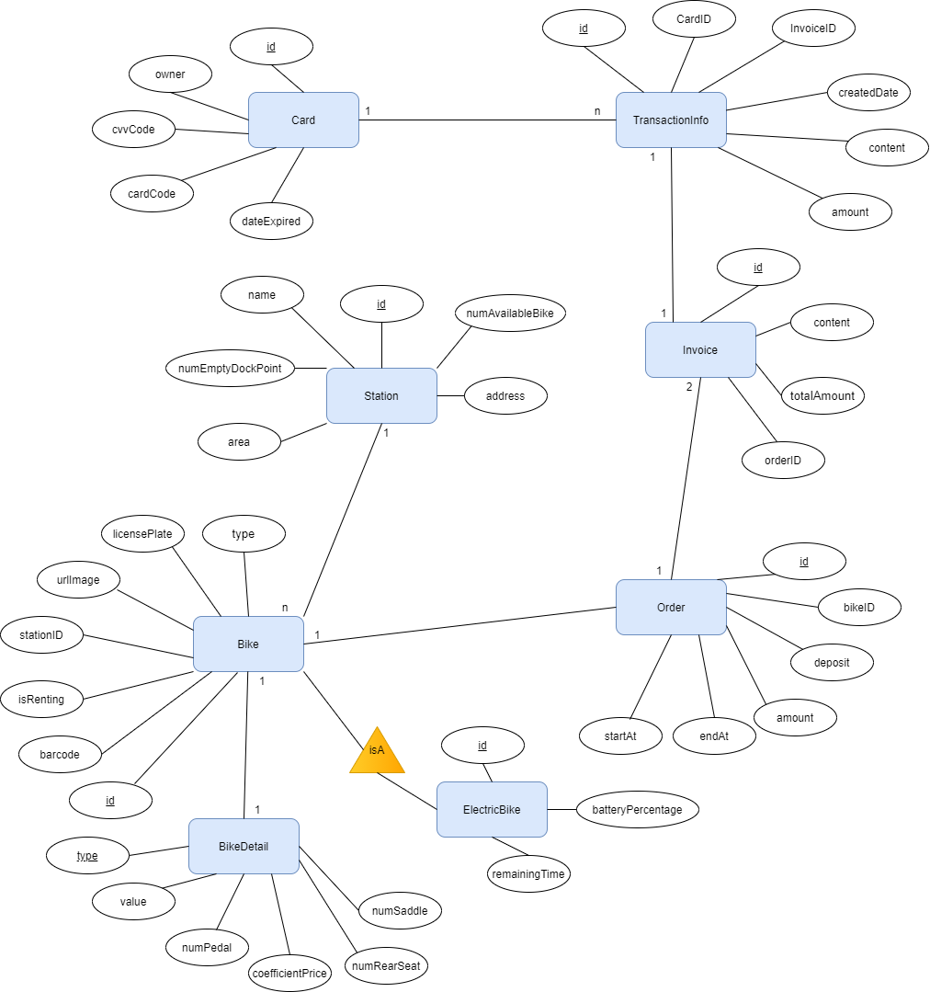

### Database Design

#### Database Management Systems

* Database Management System: MySql
* MySQL is the world's most popular open source database. With its proven performance, reliability and ease-of-use, MySQL has become the leading database choice for web-based applications, used by high profile web properties including Facebook, Twitter, YouTube, Yahoo! and many more.

#### Logical Data Model

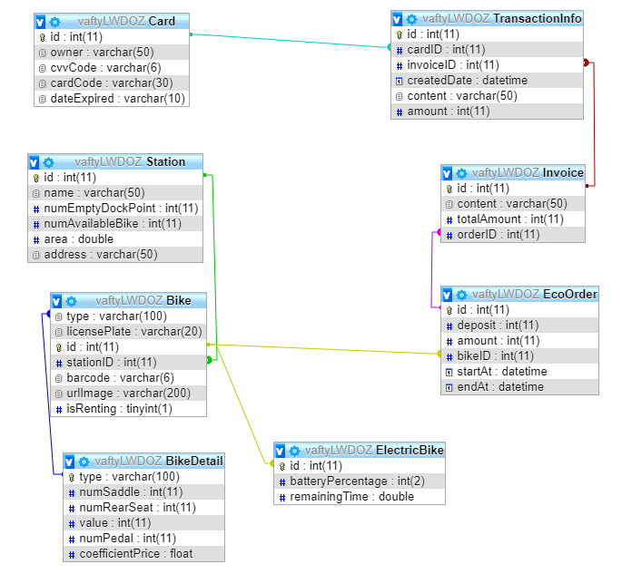

#### Physical Data Model

* **Card**

|  |  |  |  |  |  |  |
| --- | --- | --- | --- | --- | --- | --- |
| # | PK | FK | Column name | Data type | Mandatory | Description |
| 1 | x |  | id | Integer | Yes | ID of card,  auto increment |
| 2 |  |  | owner | Varchar(50) | Yes | Name of Card’s holder |
| 3 |  |  | cvvCode | Varchar(6) | Yes | Security code of card |
| 4 |  |  | cardCode | Varchar(30) | Yes | Card code number |
| 5 |  |  | dateExpired | Varchar(10) | Yes | Expiration date of card |

* **TransactionInfo**

|  |  |  |  |  |  |  |
| --- | --- | --- | --- | --- | --- | --- |
| # | PK | FK | Column name | Data type | Mandatory | Description |
| 1 | x |  | id | Integer | Yes | ID of transaction,  auto increment |
| 2 |  |  | content | Varchar(50) | Yes | Content of transaction |
| 3 |  | x | cardID | Integer | Yes | cardID, same as ID of  card which is used for the transaction |
| 4 |  | x | invoiceID | Integer | Yes | invoiceID, same as ID of invoice which belongs to the transaction |
| 5 |  |  | createDate | datetime | Yes | Creation date of  the transaction |
| 6 |  |  | amount | double | Yes | Total amount of money is used for the transaction |

* **Station**

|  |  |  |  |  |  |  |
| --- | --- | --- | --- | --- | --- | --- |
| # | PK | FK | Column name | Data type | Mandatory | Description |
| 1 | x |  | id | Integer | Yes | ID of station,  auto increment |
| 2 |  |  | name | Varchar(50) | Yes | Name of the station |
| 3 |  |  | numEmptyDockPoint | Integer | Yes | Number of empty dock points in the station |
| 4 |  |  | numAvailableBike | Integer | Yes | Number of available bike for renting in the station |
| 5 |  |  | area | double | Yes | Area of the station |
| 6 |  |  | address | varchar(50) | Yes | Address of the station |

* **Bike**

|  |  |  |  |  |  |  |
| --- | --- | --- | --- | --- | --- | --- |
| # | PK | FK | Column name | Data type | Mandatory | Description |
| 1 | x |  | id | Integer | Yes | id of the bike , auto increment |
| 2 |  | x | type | Varchar(100) | Yes | type of bike |
| 3 |  |  | licensePlate | Varchar(20) | Yes | license plate of the bike |
| 4 |  | x | stationID | Integer | Yes | Station to which this bike belongs |
| 5 |  |  | urlImage | Varchar(200) | Yes | Url of bike image |
| 6 |  |  | isRenting | Tinyint(1) | Yes | To check if the bike has been rented or not |
| 7 |  |  | Barcode | Varchar(6) | Yes | Barcode of the bike |

* **ElectricBike**

|  |  |  |  |  |  |  |
| --- | --- | --- | --- | --- | --- | --- |
| # | PK | FK | Column name | Data type | Mandatory | Description |
| 1 | x | X | id | Integer | Yes | id of the bike |
| 2 |  |  | batteryPercentage | Integer | Yes | percentage of battery |
| 3 |  |  | remainingTime | double | Yes | remaining time of the bike |

* **BikeDetail**

|  |  |  |  |  |  |  |
| --- | --- | --- | --- | --- | --- | --- |
| # | PK | FK | Column name | Data type | Mandatory | Description |
| 1 | x |  | Type | Varchar(100) | Yes | type of the bike |
| 2 |  |  | numSaddle | Integer | Yes | Number of saddle of the bike |
| 3 |  |  | numRearSeat | Integer | Yes | Number of rear seat of the bike |
| 4 |  |  | Value | Integer | Yes | Value of the bike |
| 5 |  |  | numPedal | Integer | Yes | Number of Pedal |
| 6 |  |  | coefficientPrice | Float | Yes | Coefficient when deposit |

* **Order**

|  |  |  |  |  |  |  |
| --- | --- | --- | --- | --- | --- | --- |
| # | PK | FK | Column name | Data type | Mandatory | Description |
| 1 | x |  | id | Integer | Yes | ID of order,  auto increment |
| 2 |  |  | deposit | Integer | Yes | Amount of deposit  when renting bike |
| 3 |  |  | startAt | datetime | Yes | When user rents bike |
| 4 |  |  | endAt | datetime | No | When the user returns  bike |
| 5 |  |  | Amount | Integer | No | The amount of renting  money (not include  deposit) |
| 6 |  | x | bikeID | integer | Yes | The id of the bike that  user is/was renting |

* **Invoice**

|  |  |  |  |  |  |  |
| --- | --- | --- | --- | --- | --- | --- |
| # | PK | FK | Column name | Data type | Mandatory | Description |
| 1 | x |  | id | Integer | Yes | ID of the invoice,  auto increment |
| 2 |  |  | content | Varchar(50) | Yes | The content of the  Invoice |
| 3 |  |  | totalAmount | Integer | Yes | The amount of money  for the transaction |
| 4 |  | x | orderID | Integer | Yes | The Order of which  this invoice is used for |

* **Database Script:**

CREATE TABLE `Bike` (

 `type` varchar(100) COLLATE utf8_unicode_ci DEFAULT NULL,

 `licensePlate` varchar(20) COLLATE utf8_unicode_ci DEFAULT NULL,

 `id` int(11) NOT NULL AUTO_INCREMENT,

 `stationID` int(11) DEFAULT NULL,

 `barcode` varchar(6) COLLATE utf8_unicode_ci NOT NULL,

 `urlImage` varchar(200) COLLATE utf8_unicode_ci DEFAULT NULL,

 `isRenting` tinyint(1) DEFAULT NULL,

 PRIMARY KEY (`id`),

 KEY `bike_type` (`type`),

 KEY `bike_station` (`stationID`),

 CONSTRAINT `bike_station` FOREIGN KEY (`stationID`) REFERENCES `Station` (`id`),

 CONSTRAINT `bike_type` FOREIGN KEY (`type`) REFERENCES `BikeDetail` (`type`)

) ENGINE=InnoDB AUTO_INCREMENT=18 DEFAULT CHARSET=utf8 COLLATE=utf8_unicode_ci

CREATE TABLE `BikeDetail` (

 `type` varchar(100) COLLATE utf8_unicode_ci NOT NULL,

 `numSaddle` int(11) DEFAULT NULL,

 `numRearSeat` int(11) DEFAULT NULL,

 `value` int(11) DEFAULT NULL,

 `numPedal` int(11) DEFAULT NULL,

 `coefficientPrice` float DEFAULT NULL,

 PRIMARY KEY (`type`)

) ENGINE=InnoDB DEFAULT CHARSET=utf8 COLLATE=utf8_unicode_ci

CREATE TABLE `Card` (

 `id` int(11) NOT NULL AUTO_INCREMENT,

 `owner` varchar(50) CHARACTER SET utf8 COLLATE utf8_unicode_ci NOT NULL,

 `cvvCode` varchar(6) CHARACTER SET utf8 COLLATE utf8_unicode_ci NOT NULL,

 `cardCode` varchar(30) CHARACTER SET utf8 COLLATE utf8_unicode_ci NOT NULL,

 `dateExpired` varchar(10) CHARACTER SET utf8 COLLATE utf8_unicode_ci NOT NULL,

 PRIMARY KEY (`id`)

) ENGINE=InnoDB AUTO_INCREMENT=3 DEFAULT CHARSET=utf8 COLLATE=utf8_unicode_ci

CREATE TABLE `EcoOrder` (

 `id` int(11) NOT NULL AUTO_INCREMENT,

 `deposit` int(11) NOT NULL,

 `amount` int(11) DEFAULT NULL,

 `bikeID` int(11) NOT NULL,

 `startAt` datetime NOT NULL,

 `endAt` datetime DEFAULT NULL,

 PRIMARY KEY (`id`),

 KEY `bikeID` (`bikeID`),

 CONSTRAINT `EcoOrder_ibfk_1` FOREIGN KEY (`bikeID`) REFERENCES `Bike` (`id`)

) ENGINE=InnoDB AUTO_INCREMENT=46 DEFAULT CHARSET=utf8 COLLATE=utf8_unicode_ci

CREATE TABLE `ElectricBike` (

 `id` int(11) NOT NULL,

 `batteryPercentage` int(2) DEFAULT NULL,

 `remainingTime` double DEFAULT NULL,

 PRIMARY KEY (`id`),

 CONSTRAINT `ElectricBike_ibfk_1` FOREIGN KEY (`id`) REFERENCES `Bike` (`id`)

) ENGINE=InnoDB DEFAULT CHARSET=utf8 COLLATE=utf8_unicode_ci

CREATE TABLE `Invoice` (

 `id` int(11) NOT NULL AUTO_INCREMENT,

 `content` varchar(50) COLLATE utf8_unicode_ci NOT NULL,

 `totalAmount` int(11) NOT NULL,

 `orderID` int(11) NOT NULL,

 PRIMARY KEY (`id`),

 KEY `orderID` (`orderID`),

 CONSTRAINT `Invoice_ibfk_1` FOREIGN KEY (`orderID`) REFERENCES `EcoOrder` (`id`)

) ENGINE=InnoDB AUTO_INCREMENT=104 DEFAULT CHARSET=utf8 COLLATE=utf8_unicode_ci

CREATE TABLE `Station` (

 `id` int(11) NOT NULL AUTO_INCREMENT,

 `name` varchar(50) COLLATE utf8_unicode_ci NOT NULL,

 `numEmptyDockPoint` int(11) NOT NULL,

 `numAvailableBike` int(11) NOT NULL,

 `area` double NOT NULL,

 `address` varchar(50) COLLATE utf8_unicode_ci NOT NULL,

 PRIMARY KEY (`id`)

) ENGINE=InnoDB AUTO_INCREMENT=21 DEFAULT CHARSET=utf8 COLLATE=utf8_unicode_ci

CREATE TABLE `TransactionInfo` (

 `id` int(11) NOT NULL AUTO_INCREMENT,

 `cardID` int(11) DEFAULT NULL,

 `invoiceID` int(11) DEFAULT NULL,

 `createdDate` datetime DEFAULT NULL,

 `content` varchar(50) COLLATE utf8_unicode_ci DEFAULT NULL,

 `amount` int(11) DEFAULT NULL,

 PRIMARY KEY (`id`),

 KEY `cardID` (`cardID`),

 KEY `invoiceID` (`invoiceID`),

 CONSTRAINT `TransactionInfo_ibfk_1` FOREIGN KEY (`cardID`) REFERENCES `Card` (`id`),

 CONSTRAINT `TransactionInfo_ibfk_2` FOREIGN KEY (`invoiceID`) REFERENCES `Invoice` (`id`)

) ENGINE=InnoDB AUTO_INCREMENT=36 DEFAULT CHARSET=utf8 COLLATE=utf8_unicode_ci

## Non-Database Management System Files

## Class Design

### General Class Diagram

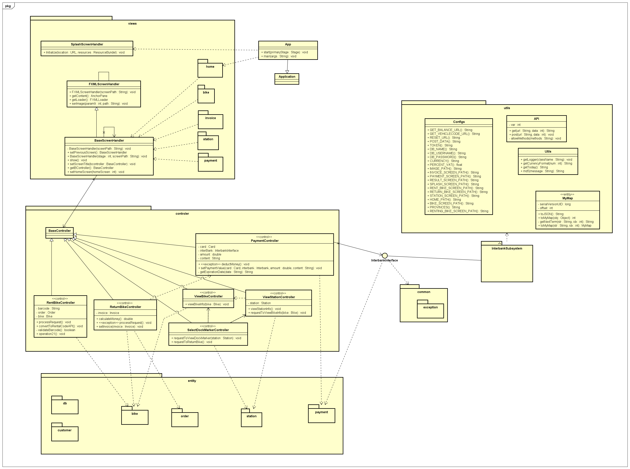

### Class Diagrams

#### Class Diagram for Interbank Subsystem

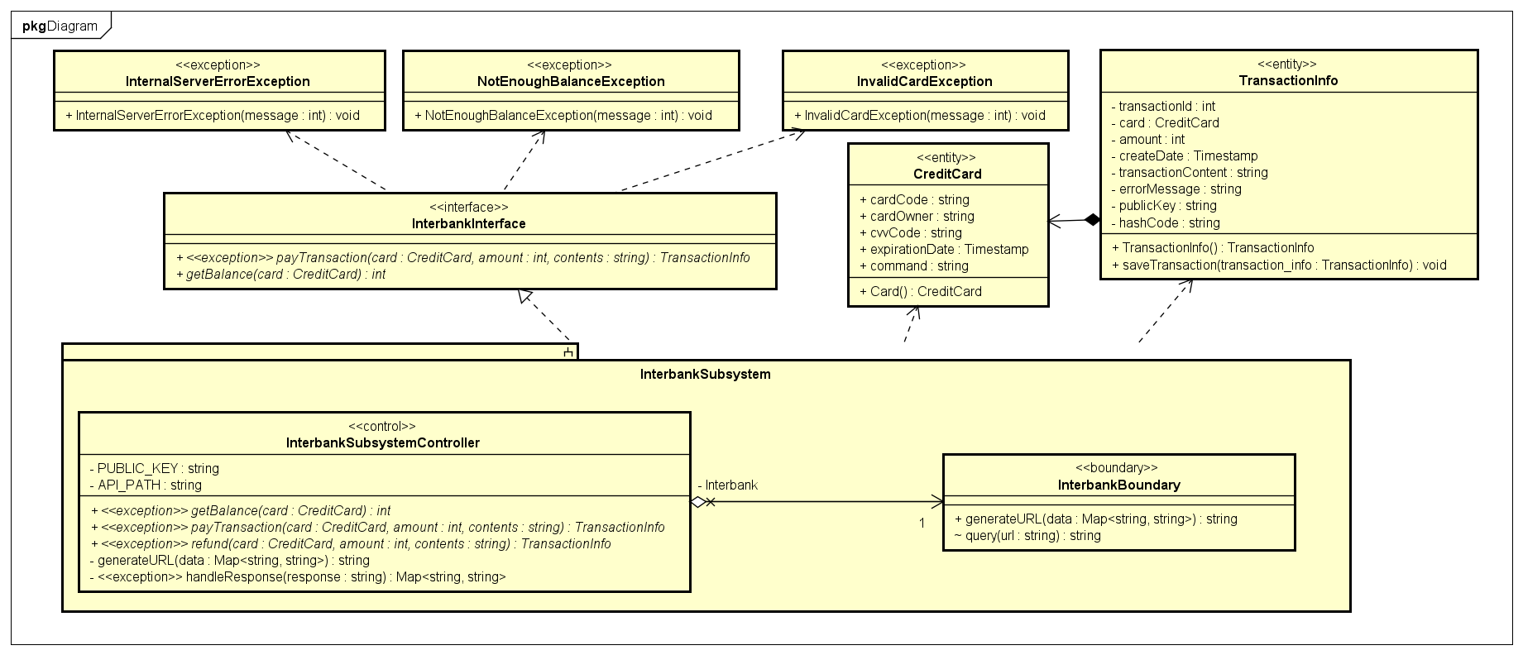

#### Class Diagram for Entity package

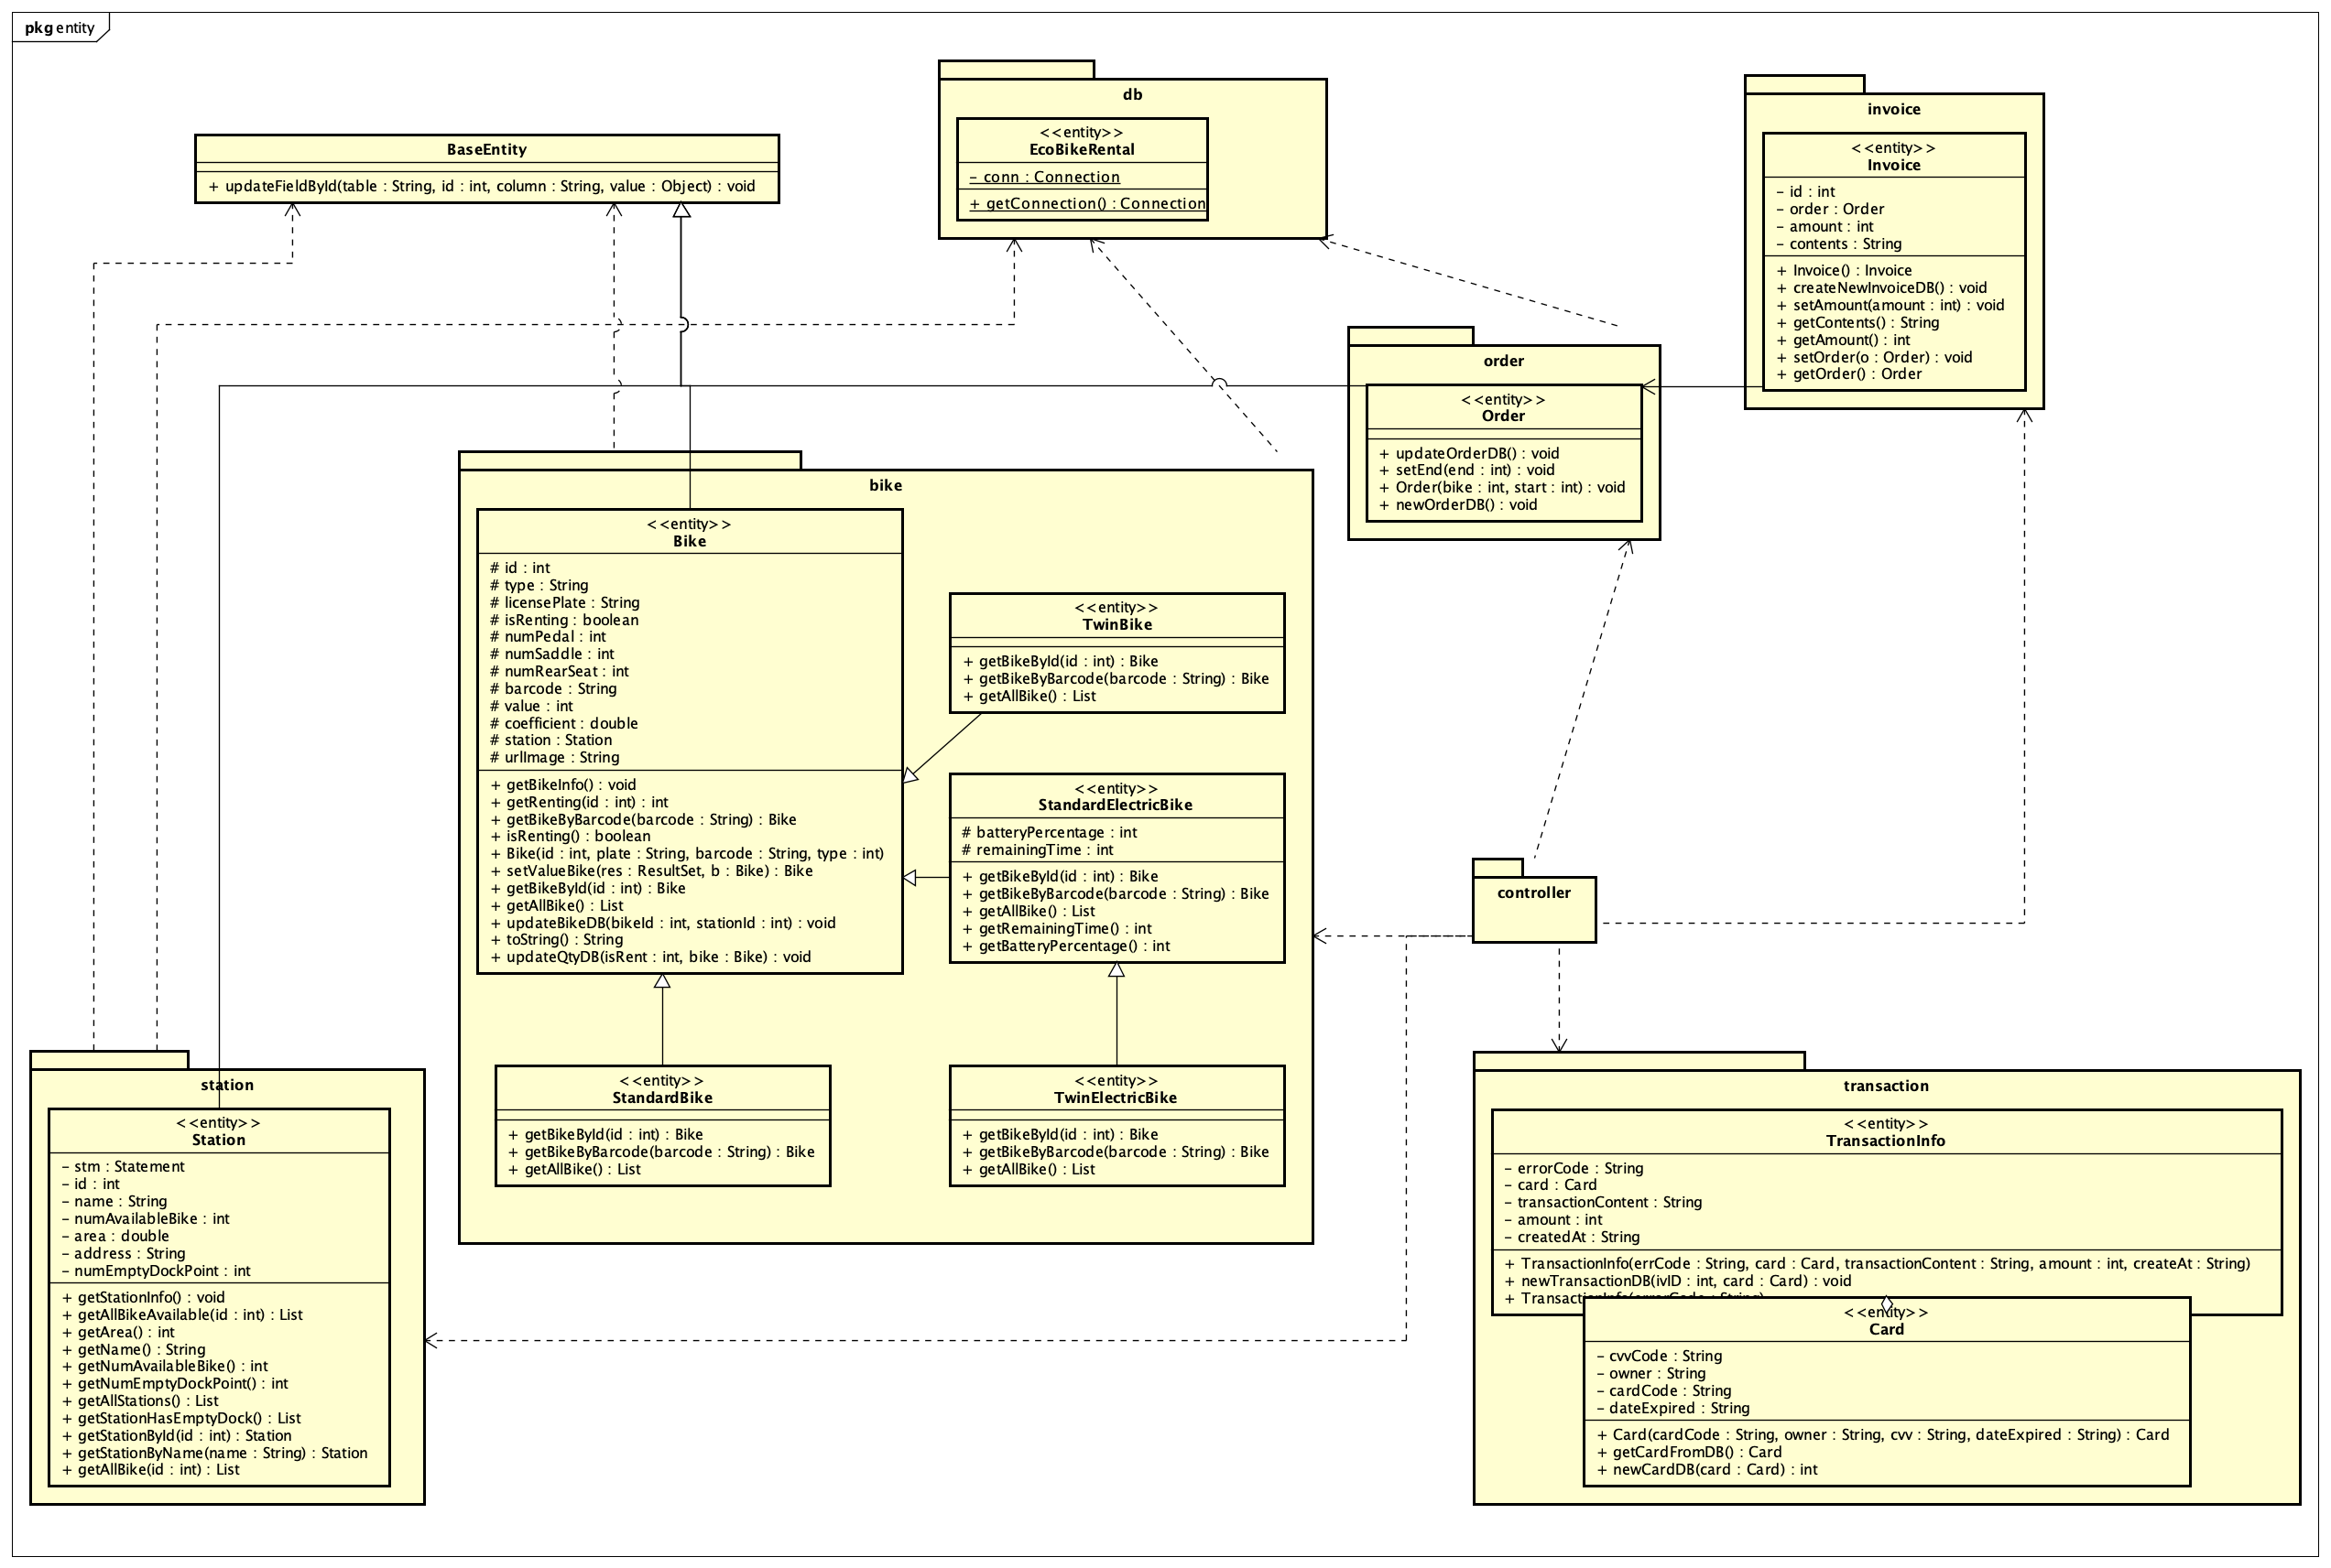

#### Class Diagram for Controller package

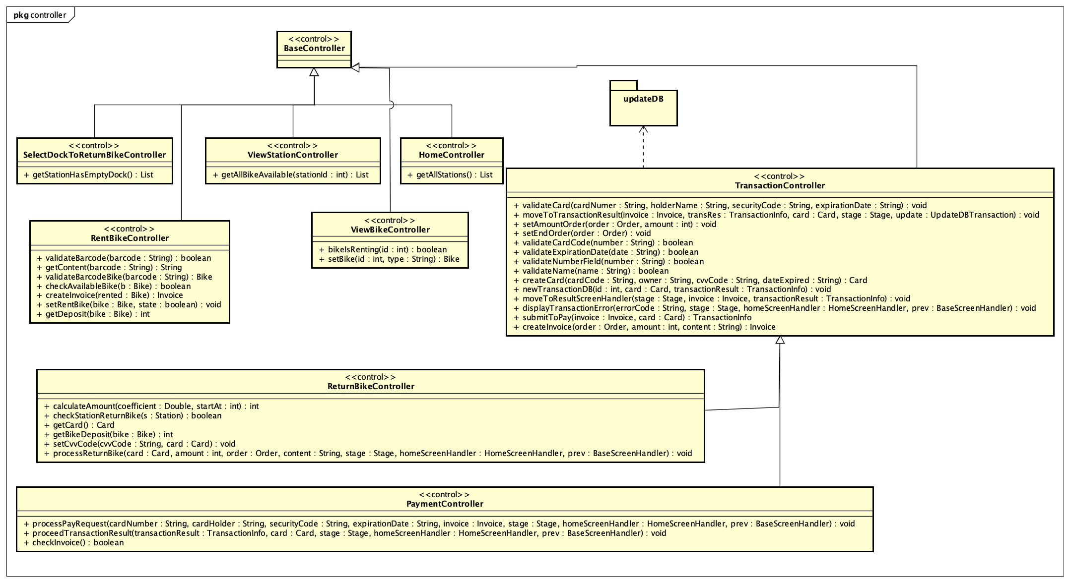

#### Class Diagram for Screen package

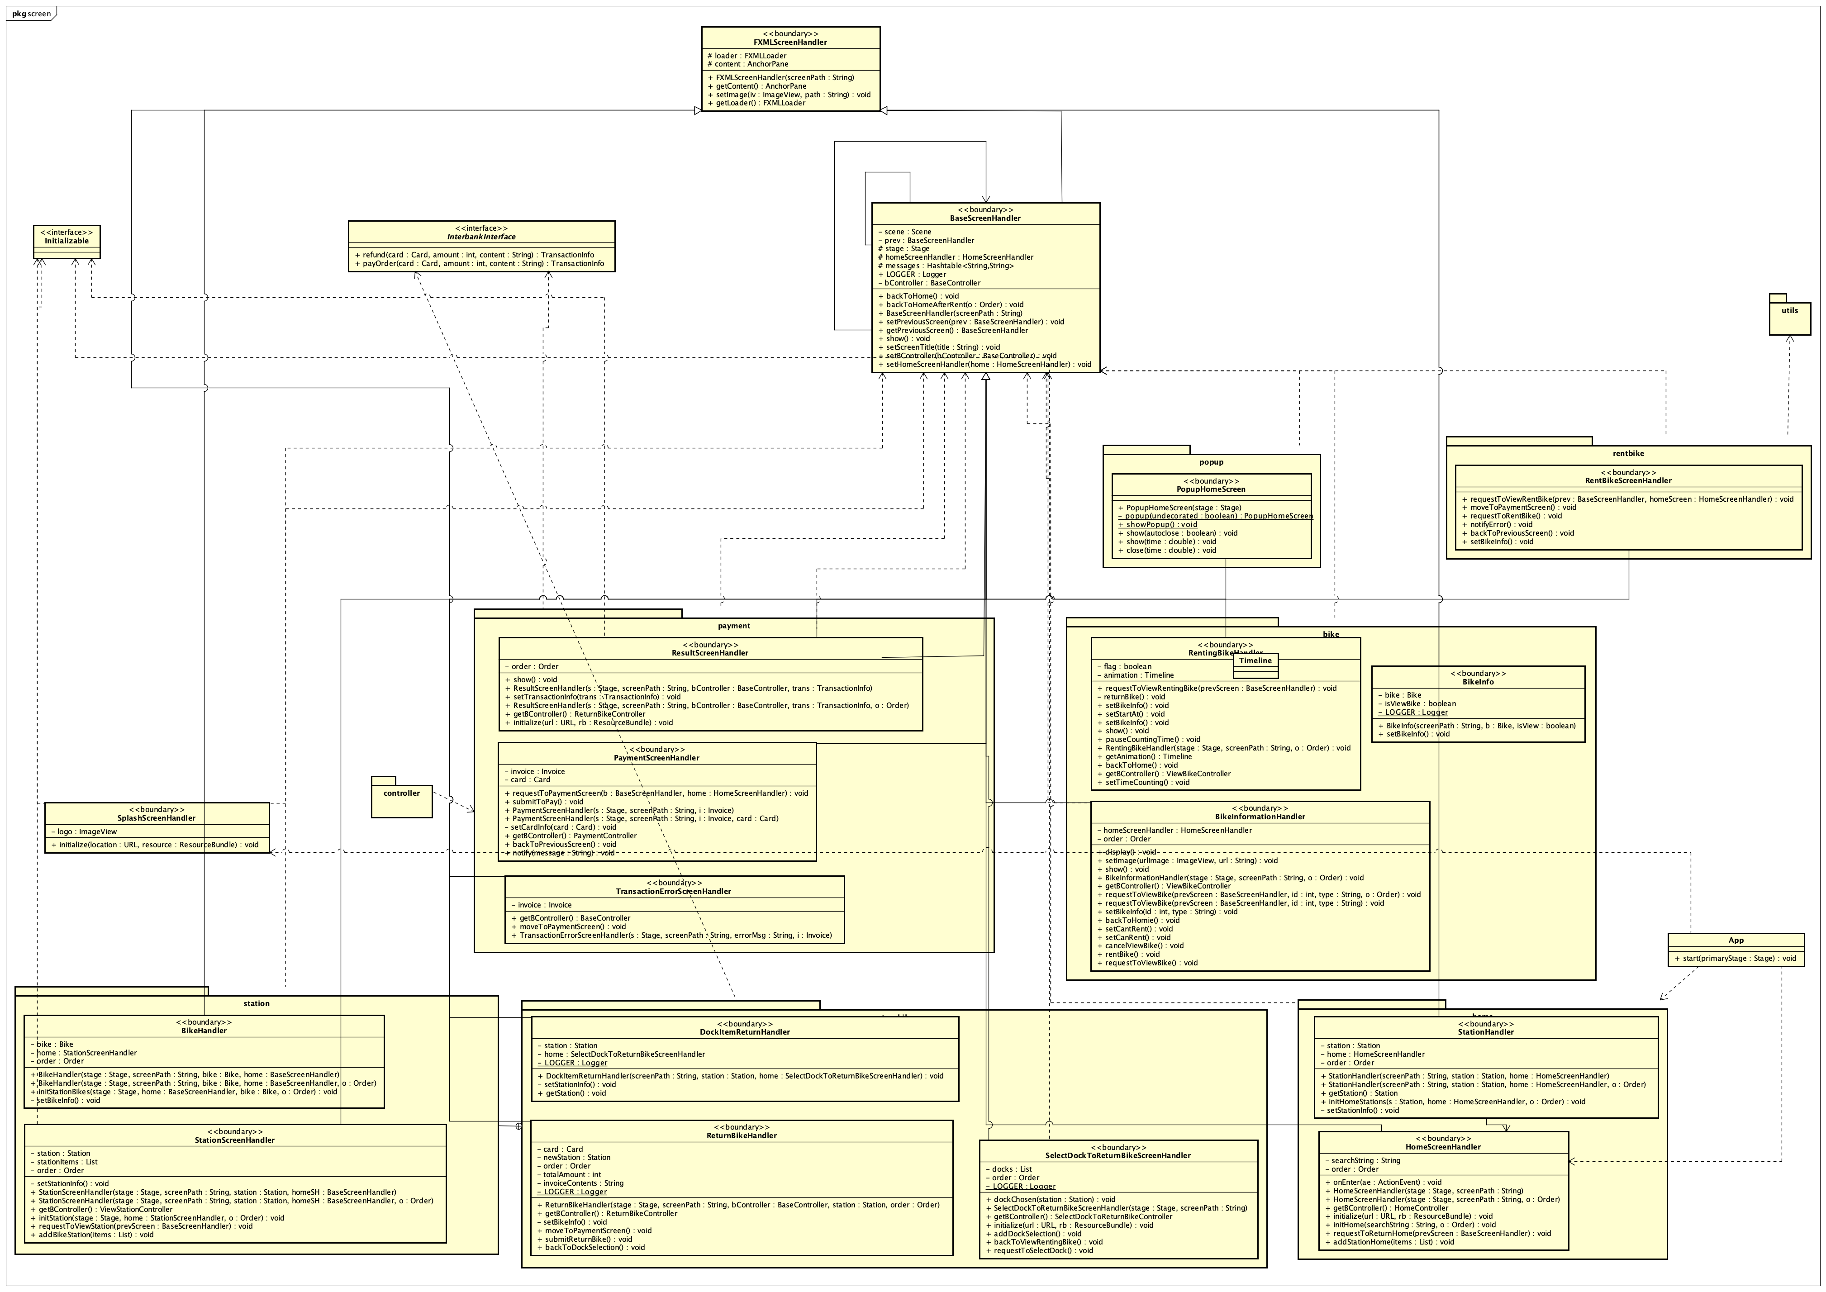

### Class Design

#### Class “PaymentController”



***Operation***

|  |  |  |  |
| --- | --- | --- | --- |
| # | Name | Return type | Description (purpose) |
| 1 | processPayRequest | void | Process pay request from user |
| 2 | proceedTransactionResult | void | Process transaction result, decide which screen to go |

*Exception*: None

*Parameter*:

* card – the credit card used for payment
* stage – stage of screen
* homeScreenHandler – home screen handler
* prev – base screen handler
* transactionResult – result of transaction use to process
* cardNumber – number of card
* cardHolder – card’s owner
* securityCode – cvvCode
* expirationDate – date expired of card
* invoice – Invoice of pay request

***State :*** None

***Method :*** None

#### Class “RentBikeController”

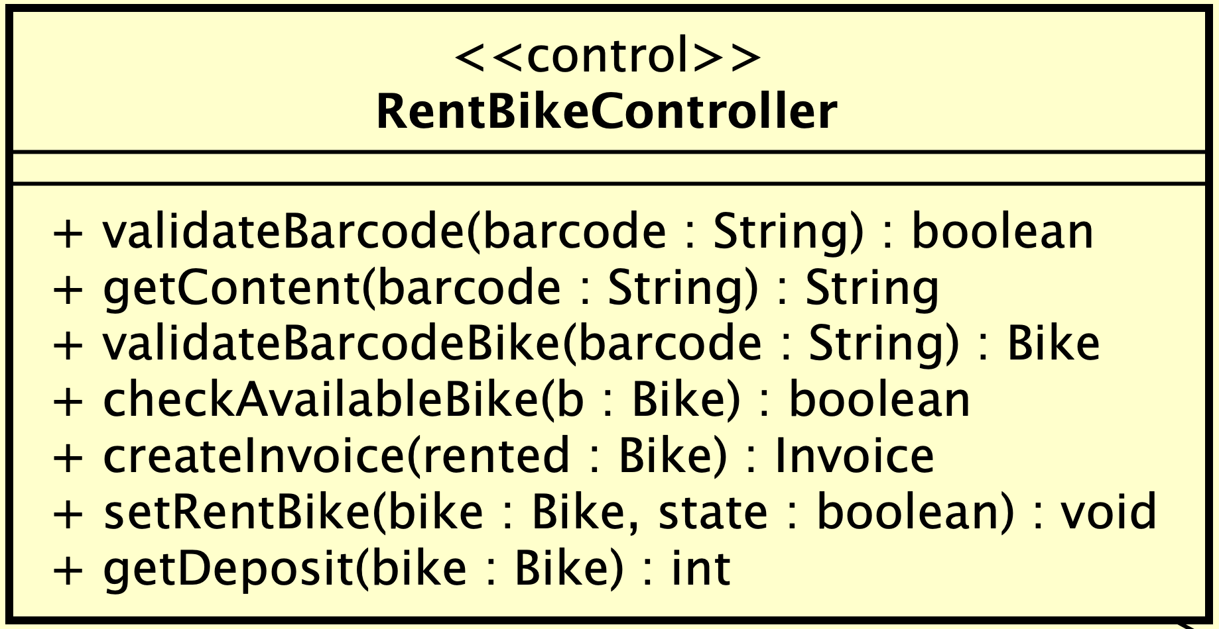

***Attribute***

***Operation***

|  |  |  |  |
| --- | --- | --- | --- |
| # | Name | Return type | Description (purpose) |
| 1 | validateBarcode | boolean | Validate input barcode |
| 2 | getContent | String | Get content for the order |
| 3 | validateBarcodeBike | Bike | Get bike from given barcode |
| 4 | CheckAvailableBike | boolean | Check if bike has been rented or not |
| 5 | createInvoice | Invoice | Create invoice for transaction |
| 6 | setRentBike | void | Set isRenting for bike |
| 7 | getDeposit | int | Get deposit amount of bike |

*Parameter*:

* Barcode: barcode use to rent bike
* Bike : bike use to rent
* State: state set for *isRenting* attribute of bike

*Exception*: None

***Method:*** None

***State:*** None

#### Class “ReturnBikeController”

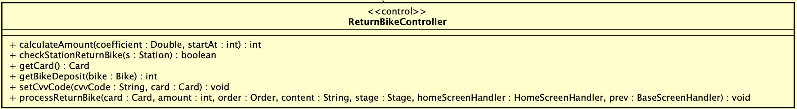

***Attribute***

***Operation***

|  |  |  |  |
| --- | --- | --- | --- |
| # | Name | Return type | Description (purpose) |
| 1 | calculateAmount | int | Calculate total amount that customer has to pay when return bike |
| 2 | processReturnBike | void | Process returning bike request |
| 3 | checkStationReturnBike | boolean | check station have empty dock point to return bike |
| 4 | getCard | Card | Get card’s information from database |
| 5 | setCvvCode | void | Set cvvCode for card from user |
| 6 | getBikeDeposit | int | Get deposit of given bike |

*Parameter*:

* Coefficient: coefficient of bike use to calculate total amount
* StartAt: start time when renting bike
* S: station will use to check for return bike
* Bike: Bike use for get deposit
* Card: Card use for transaction
* Amount: total amount user has to pay
* Order: Order use to make invoice
* Content: content of invoice
* stage – stage of screen
* homeScreenHandler – home screen handler
* prev – base screen handler

*Exception*: None

***State:*** None

***Method:*** None

#### Class “ViewStationController”

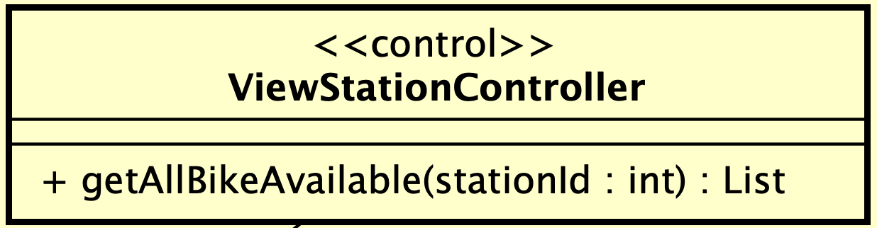

***Attribute***

***Operation***

|  |  |  |  |
| --- | --- | --- | --- |
| # | Name | Return type | Description (purpose) |
| 1 | getAllBikeAvailable | List | Get all bikes are available for renting |

*Parameter*:

* StationId: id of station use to get bike list

*Exception*: None

***Method*** None

***State*** None

#### Class “HomeController”

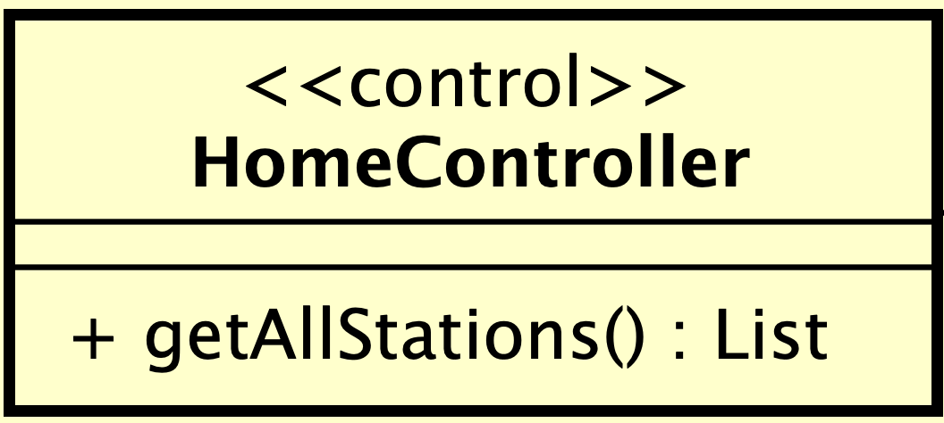

***Attribute***

***Operation***

|  |  |  |  |
| --- | --- | --- | --- |
| # | Name | Return type | Description (purpose) |
| 1 | getAllStations | List | Get all stations to display |

*Parameter*: None

*Exception*: None

***Method*** None

***State*** None

#### Class “SelectDockToReturnBikeController”

***Attribute***

***Operation***

|  |  |  |  |
| --- | --- | --- | --- |
| # | Name | Return type | Description (purpose) |
| 1 | getStationHasEmptyDock | List | Get all stations have empty dock to return bike |

*Parameter*: None

*Exception*: None

***Method:*** None

***State:*** None

#### Class “ViewBikeController”

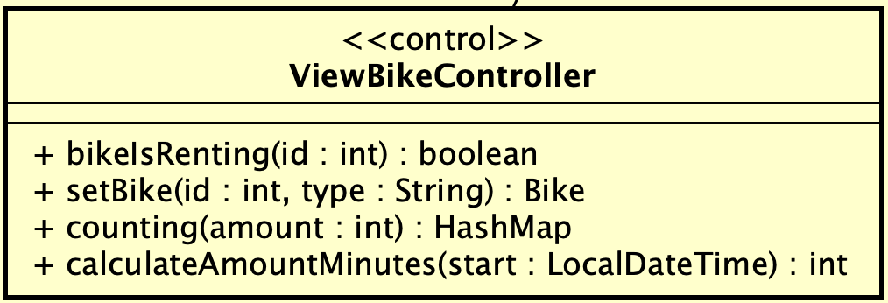

***Attribute***

***Operation***

|  |  |  |  |
| --- | --- | --- | --- |
| # | Name | Return type | Description (purpose) |
| 1 | bikeIsRenting | boolean | Check if a bike is renting by id |
| 2 | setBike | Bike | create bike instance base on id and type |
| 3 | counting | HashMap | count 1 second |
| 4 | calculateAmountMinutes | int | convert time in localDateTime to second |

*Parameter*:

* Id: id of bike
* Type: type of the bike
* Amount: amount that wants to count
* Start: start time use for counting

*Exception*: None

***Method:*** None

***State:*** None

#### Class “TransactionController”

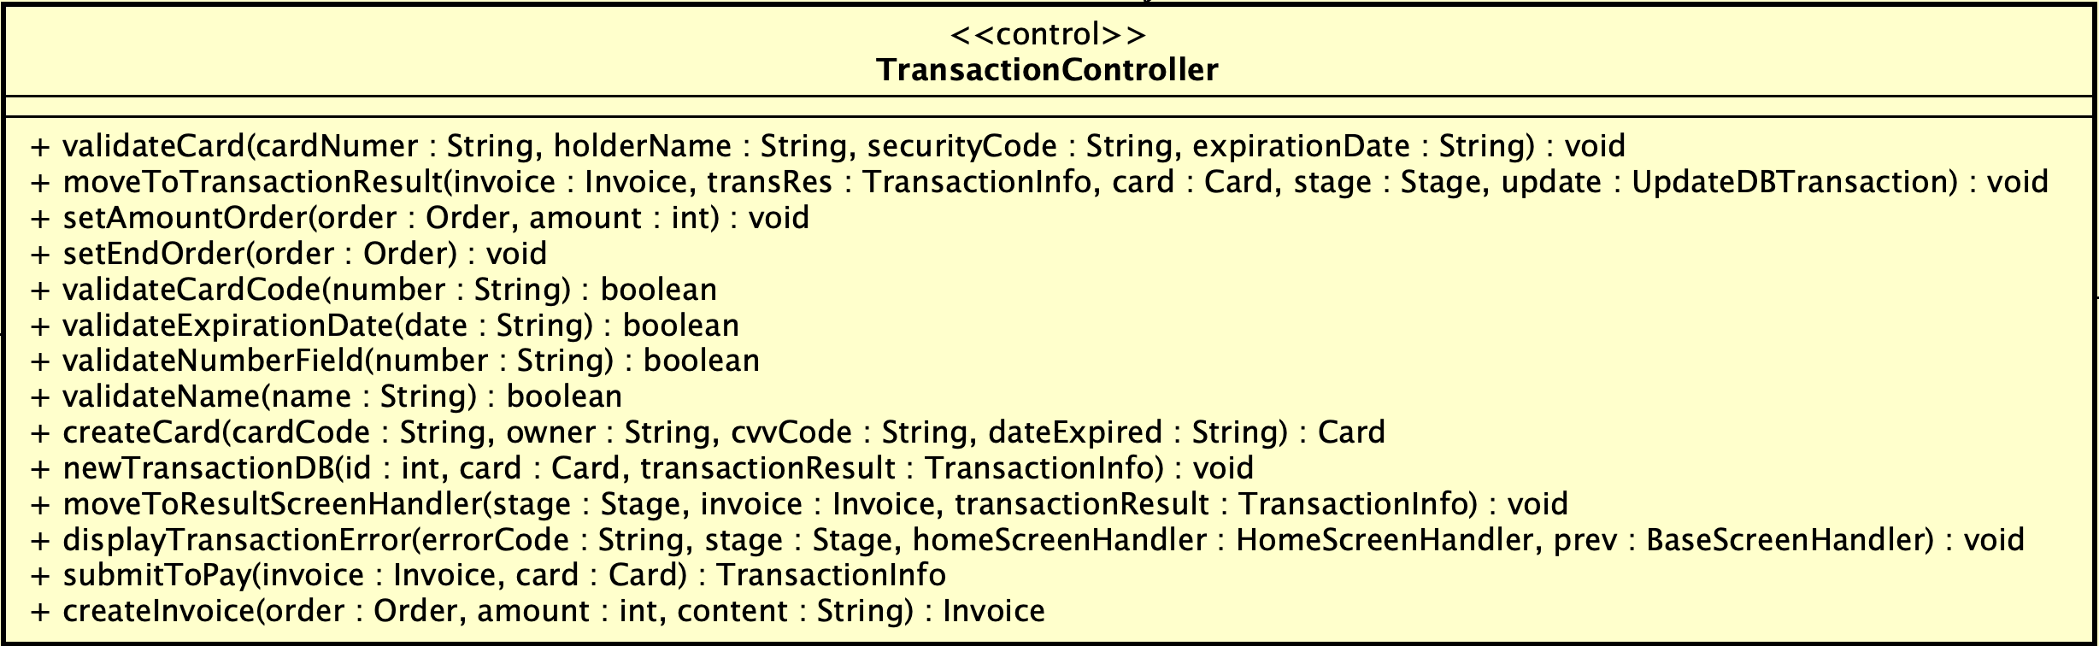

**Attribute**

**Operation**

|  |  |  |  |
| --- | --- | --- | --- |
| # | Name | Return type | Description (purpose) |
| 1 | validateCard | void | Validate card |
| 2 | moveToTransactionResult | void | Move to TransactionResult screen |
| 3 | setAmountOrder | void | Set amount for order |
| 4 | setEndOrder | void | Set end time for order |
| 5 | validateCardCode | boolean | Validate card code |
| 6 | validateExpirationDate | boolean | Validate expiration date |
| 7 | validateNumberField | boolean | validate Security Code/cvvCode |
| 8 | validateName | boolean | Validate card’s owner |
| 9 | createCard | Card | Create new card |
| 10 | newTransactionDB | void | insert newTransaction to database |
| 11 | moveToResultScreenHandler | void | move to resultScreenHandler |
| 12 | displayTransactionError | void | move to transaction error screen |
| 13 | submitToPay | TransactionInfo | Submit to pay for transaction |
| 14 | createInvoice | Invoice | create invoice |

*Parameter*:

* card – the credit card used for payment
* stage – stage of screen
* homeScreenHandler – home screen handler
* prev – base screen handler
* transactionResult – result of transaction use to process
* cardNumber – number of card
* cardHolder – card’s owner
* securityCode – cvvCode
* expirationDate – date expired of card
* invoice – Invoice of pay request
* TransRes – transaction result
* Update – UpdateDBTransaction interface
* ErrorCode – error code responsed when process transaction
* Amount – total amount of transaction
* Number – input for validation

*Exception*: None

**Method:** none

**State:** none

#### Class “UpdateDBTransaction”

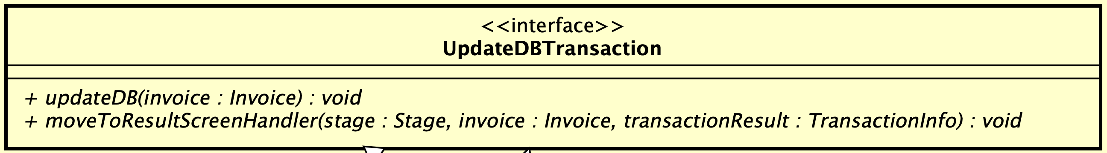

**Attribute**

**Operation**

|  |  |  |  |
| --- | --- | --- | --- |
| # | Name | Return type | Description (purpose) |
| 1 | updateDB | void | insert invoice, insert/update order of the invoice to database |
| 2 | moveToResultScreenHandler | void | Move to result screen |

*Parameter*

* Invoice: invoice use to update database
* Stage: stage of screen
* TransactionResult: result of transaction

*Exception*: none

**Method:** none

**State:** none

#### Class “BikeHandler”

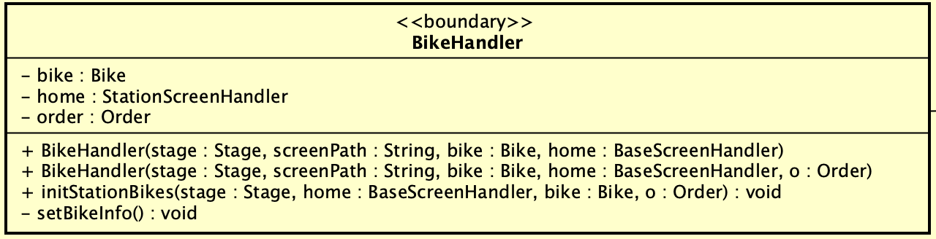

**Attribute**

|  |  |  |  |  |
| --- | --- | --- | --- | --- |
| # | Name | Data type | Default value | Description |
| 1 | bike | Bike | NULL | Bike whose infomation will be displayed |
| 2 | order | Order | NULL | Order of renting bike if any |
| 3 | home | StationScreenHandler | NULL | StationScreenHandler which BikeHandler attached to |

**Operation**

|  |  |  |  |
| --- | --- | --- | --- |
| # | Name | Return type | Description (purpose) |
| 1 | initStationBikes | void | initialize station with bikes |
| 2 | setBikeInfo | void | Set information of bike to screen |

*Parameter*

* bike - current bike
* stage – stage of screen
* homeScreenHandler – home screen handler
* O – current order

**Method:** none

**State:** none

#### Class“StationScreenHandler”

**Attribute**

|  |  |  |  |  |
| --- | --- | --- | --- | --- |
| # | Name | Data type | Default value | Description |
| 1 | stationItems | List | NULL | List of all stations |
| 2 | order | Order | NULL | Current order if any |
| 3 | station | Station | NULL | Current station |

**Operation**

|  |  |  |  |
| --- | --- | --- | --- |
| # | Name | Return type | Description (purpose) |
| 1 | getBController | ViewStationController | Get base controller |
| 2 | setStationInfo | void | Set station information |
| 3 | initStation | void | Initial station information |
| 4 | requestToViewStation | void | Request to view a station |
| 5 | addBikeStation | void | Add bike to station |

*Parameter*:

* stage – stage of screen
* ScreenPath – path to fxml screen
* homeSH - base screen handler
* O - current order
* Items – list of bikes add to station

**Method:** none

#### Class “SplashScreenHandler”

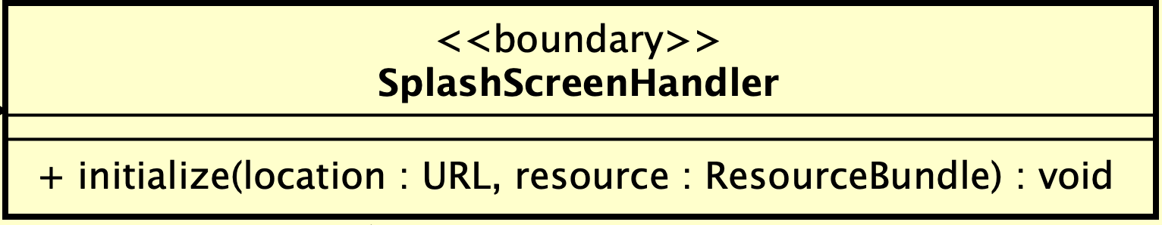

**Attribute**

**Operation:**

**Method:** none

**State:** none

#### Class “FXMLScreenHandler”

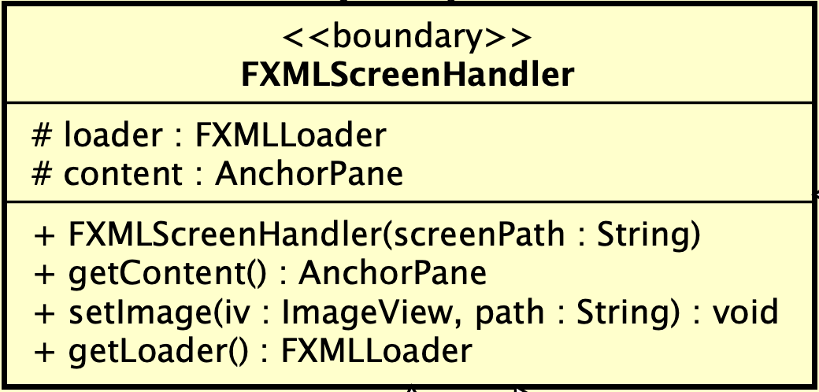

***Attribute***

|  |  |  |  |  |
| --- | --- | --- | --- | --- |
| # | Name | Data type | Default value | Description |
| 1 | loader | FXMLLoader | null |  |
| 2 | content | AnchorPane | null |  |

**Operation:**

|  |  |  |  |
| --- | --- | --- | --- |
| # | Name | Return type | Description (purpose) |
| 1 | getContent | AnchorPane | Get content of anchorPane |
| 2 | setImage | void | Set image to ImageView |
| 3 | getLoader | FXMLLoader | Get loader |

*Parameter*:

* ScreenPath – path to fxml screen
* iv – image view
* Path – path to image use to set

**Method:** none

**State:** none

#### Class “BarcodeScreenHandler”

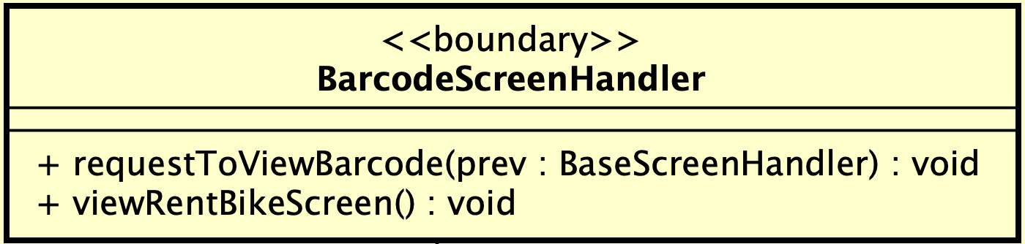

**Attribute**

**Operation:**

|  |  |  |  |
| --- | --- | --- | --- |
| # | Name | Return type | Description (purpose) |
| 1 | requestToViewBarcode | void | move to the barcode screen |
| 2 | viewRentBikeScreen | void | move to the rent bike screen |

*Parameter*:

* prev – base screen handler

**Method:** none

**State:** none

#### Class “PopupHomeScreen”

**Attribute**

**Operation**

|  |  |  |  |
| --- | --- | --- | --- |
| # | Name | Return type | Description (purpose) |
| 1 | popup | PopupHomeScreen | style the pop-up |
| 2 | showPopup | void | Show popup |
| 3 | show | void | show and auto close after sometime |
| 4 | show | void | show and close after sometime |
| 5 | close | void | close the pop-up after sometime |

*Parameter*

* Stage: current stage
* Autoclose: set autoclose for popup
* Time: amount of time that popup will close

*Exception*: none

**Method:** none

**State:** none

#### Class “RentBikeScreenHandler”

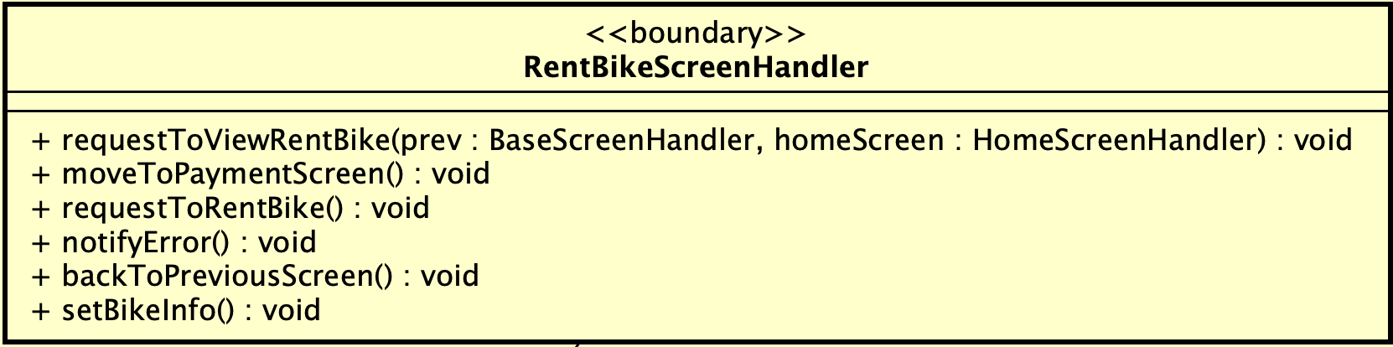

**Attribute**

**Operation**

|  |  |  |  |
| --- | --- | --- | --- |
| # | Name | Return type | Description (purpose) |
| 1 | notifyError | void | Notify error |
| 2 | requestToViewRentBike | Void | Process to request to view renting bike information |
| 3 | moveToPaymentScreen | void | Move to payment screen |
| 4 | requestToRentBike | void | Request to rent bike |
| 5 | backToPreviousScreen | void | Back to previous screen |
| 6 | setBikeInfo | void | Set bike’s information |

*Parameter*

* Prev – BaseScreenHandler
* HomeScreen - HomeScreenHandler

**Method:** none

**State:** none

#### Class “BaseScreenHandler”

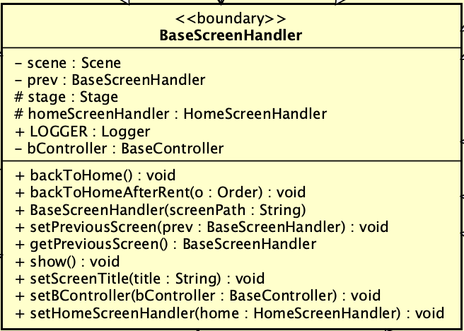

**Attribute**

|  |  |  |  |  |
| --- | --- | --- | --- | --- |
| # | Name | Data type | Default value | Description |
| 1 | scene | Scene | NULL | scene |
| 2 | prev | BaseScreenHandler | NULL | Previous screen |
| 3 | stage | Stage | NULL | Current stage |
| 4 | homeScreenHandler | HomeScreenHandler | NULL | Home screen handler |
| 5 | LOGGER | Logger | NULL | Logger |
| 6 | bController | BaseController | NULL | Base controller |

**Operation**

|  |  |  |  |
| --- | --- | --- | --- |
| # | Name | Return type | Description (purpose) |
| 1 | backToHome | void | Back to home before renting |
| 2 | backToHomeAfterRent | void | Back to home after renting |
| 3 | setPreviousScreen | void | Set previous screen |
| 4 | getPreviousScreen | BaseScreenHandler | get previous screen |
| 5 | show | void | Show this screen |
| 6 | setScreenTitle | void | Set title for screen |
| 7 | setBController | void | Set bController |
| 8 | setHomeScreenHandler | void | Set home screen |

*Parameter*

* Prev – BaseScreenHandler
* HomeScreen - HomeScreenHandler
* Order – current order
* ScreenPath – path to file fxml screen
* Title – title of screen
* BController – BaseController

**Method:** none

**State:** none

#### Class “HomeScreenHandler”

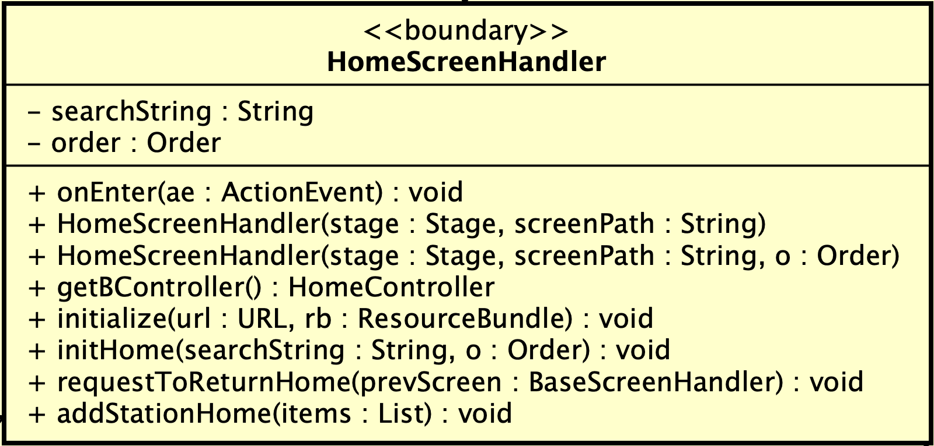

**Attribute**

|  |  |  |  |  |
| --- | --- | --- | --- | --- |
| # | Name | Data type | Default value | Description |
| 1 | searchString | String | null | String use to search |
| 2 | order | Order | null | Current order if any |

**Operation**

|  |  |  |  |
| --- | --- | --- | --- |
| # | Name | Return type | Description (purpose) |
| 1 | onEnter | void | Search station by name on enter to input field |
| 2 | initHome | Void | Initialize home screen |
| 3 | requestToReturnHome | void | Process request to return home screen |
| 4 | addStationHome | Void | Add stations to home screen |

*Parameter*

* stage – stage of screen
* ScreenPath – path to fxml screen
* SearchString – input string use to search
* Items – list of stations

**Method:** none

**State:** none

#### Class “StationHandler”

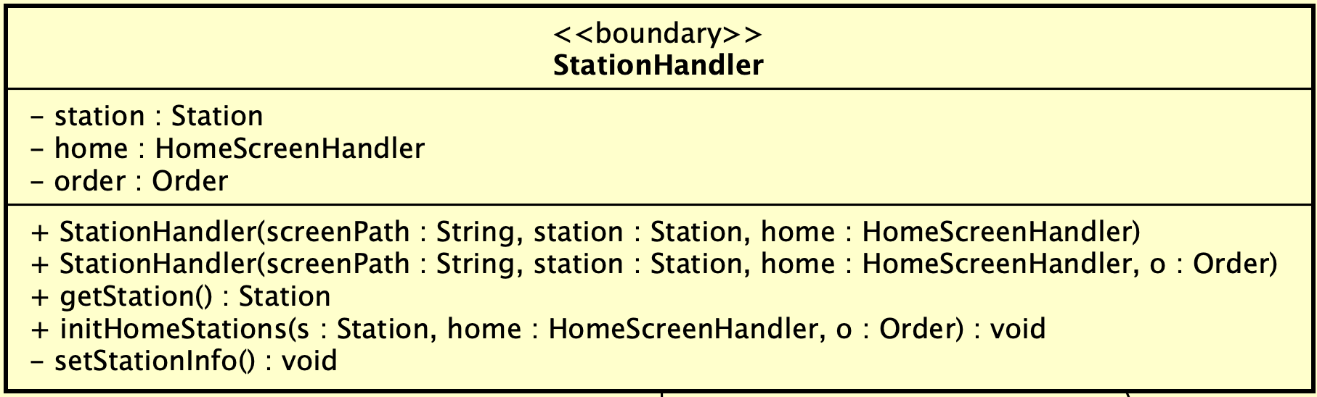

**Attribute**

|  |  |  |  |  |
| --- | --- | --- | --- | --- |
| # | Name | Data type | Default value | Description |
| 1 | station | Station | null | Current station |
| 2 | order | Order | null | Current order if any |
| 3 | home | HomeScreenHandler | Null | Home screen |

**Operation**

|  |  |  |  |
| --- | --- | --- | --- |
| # | Name | Return type | Description (purpose) |
| 1 | getStation | Station | Get current station |
| 2 | initHomeStations | void | initialize stations in home screen |

*Parameter:*

* stage – stage of screen
* ScreenPath – path to fxml screen
* Home – Home Screen handler
* o – current order
* s – current station

**Method:** none

**State:** none

#### ***Class “ReturnBikeHandler”***

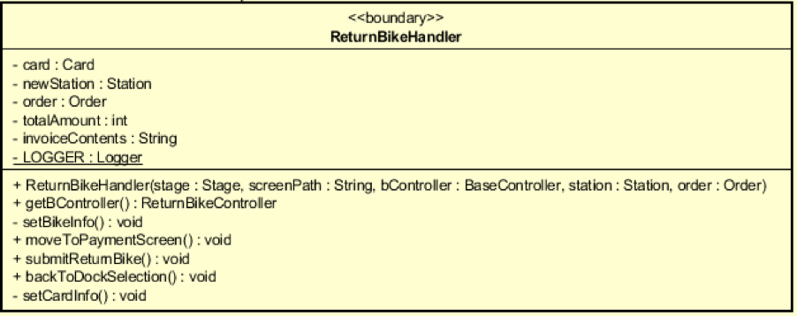

**Attribute**

|  |  |  |  |  |
| --- | --- | --- | --- | --- |
| # | Name | Data type | Default value | Description |
| 1 | card | Card | NULL | The card used for returning bike |
| 2 | newStation | Station | NULL | The station which the bike returns to |
| 3 | order | Order | NULL | The order of returning bike |
| 4 | totalAmount | String | NULL | The total amount that user has to pay when reting bike |
| 5 | invoiceContents | String | NULL | Invoice Contents, could be pay or refund |
| 6 | Logger | LOGGER | NULL | For logging purpose |

**Operation**

|  |  |  |  |
| --- | --- | --- | --- |
| # | Name | Return type | Description (purpose) |
| 1 | ReturnBikeHandler |  | Constructor |
| 2 | GetBController | ReturnBikeController | Set the controller for this screen |
| 3 | setBikeInfo | void | Set the bike info for displaying |
| 4 | moveToPaymentScreen | void | Move to payment screen |
| 5 | submitToReturnBike | void | handle the process when user click submit to return bike |
| 6 | backToDockSelection | Bike | Handle the process when user want to choose another station to return bike |
| 7 | setCardInfo | Void | Set the card info for displaying in the screen |

**Method:** none

**State:** none

***4.4.3.21 Class “DockItemReturnHandler”***

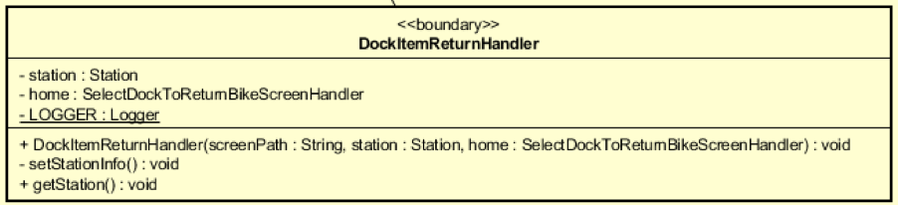

**Attribute**

|  |  |  |  |  |
| --- | --- | --- | --- | --- |
| # | Name | Data type | Default value | Description |
| 1 | station | Station | NULL | The station we want to display |
| 2 | home | SelectDockToReturnBikeScreenHandler | NULL | The root screen which use this screen to display station |
| 3 | Logger | LOGGER | NULL | For logging purpose |

**Operation**

|  |  |  |  |
| --- | --- | --- | --- |
| # | Name | Return type | Description (purpose) |
| 1 | DockItemReturnHandler |  | Constructor |
| 2 | setStationInfo | Void | Set the info we want to display |
| 3 | getStation | Void | Get the current Station |

**Method:** none

**State:** none

***4.4.3.22 Class “*** ***SelectDockToReturnBikeScreenHandler”***

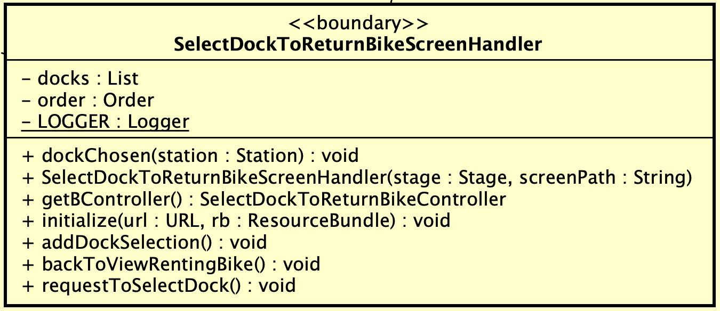

**Attribute**

|  |  |  |  |  |
| --- | --- | --- | --- | --- |
| # | Name | Data type | Default value | Description |
| 1 | docks | List[Station] | NULL | A list of stations that user can return bike to |
| 2 | order | Order | NULL | The current order, while renting bike |
| 3 | Logger | LOGGER | NULL | For logging purpose |

**Operation**

|  |  |  |  |
| --- | --- | --- | --- |
| # | Name | Return type | Description (purpose) |
| 1 | dockChosen | Void | Move to the return bike screen when a station is chosen |
| 2 | SelectDockToReturnBikeScreenHandler |  | Constructor |
| 3 | getBController | SelectDockToReturnBikeController | Set the controller for this screen |
| 4 | initialize | void | initialize the content of the screen |
| 5 | addDockSeletion | void | Display list of station for user to choose |
| 6 | backToViewRentingBike | Void | Back to previous screen, which is view renting bike screen |
| 7 | requestToSelectDock | Void | Request to move to this screen |

**Method:** none

**State:** none

***4.4.3.23*** Class “RentingBikeHandler”

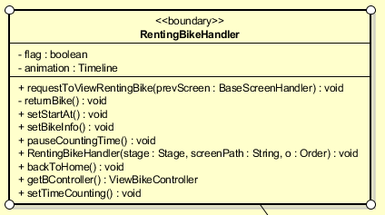

**Attribute**

|  |  |  |  |  |
| --- | --- | --- | --- | --- |
| # | Name | Data type | Default value | Description |
| 1 | flag | Boolean | NULL | For stop renting bike purpose |
| 2 | Animation | Timeline | NULL | For display time purpose |

**Operation**

|  |  |  |  |
| --- | --- | --- | --- |
| # | Name | Return type | Description (purpose) |
| 1 | requestToViewRentingBike | Void | Request to move to this screen |
| 2 | returnBike | Void | Request to move to select dock to return bike screen |
| 3 | setBikeInfo | void | Set the bike info for displaying |
| 4 | setStartAt | void | Set start time for time displaying |
| 5 | pauseCountingTime | void | For pause and continue renting time |
| 6 | RentingBikeHandler |  | Contructor |
| 7 | backToHome | Void | Back to home screen |
| 8 | getBController | ViewBikeController | Set controller for this screen |
| 9 | setTimeCoungting | Void | Set the counting time on the screen |

**Method:** none

**State:** none

***4.4.3.24 Class “BikeInfo”***

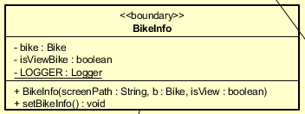

**Attribute**

|  |  |  |  |  |
| --- | --- | --- | --- | --- |
| # | Name | Data type | Default value | Description |
| 1 | bike | Bike | NULL | The bike we want to display |
| 2 | isViewBike | Boolean | NULL | To check if this bike is the viewing bike |
| 3 | Logger | LOGGER | NULL | For logging purpose |

**Operation**

|  |  |  |  |
| --- | --- | --- | --- |
| # | Name | Return type | Description (purpose) |
| 1 | BikeInfo |  | Constructor |
| 2 | setBikeInfo | Void | Set the info we want to display |

**Method:** none

**State:** none

***4.4.3.25 Class “*** ***BikeInformationHandler”***

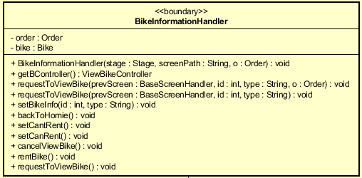

**Attribute**

|  |  |  |  |  |
| --- | --- | --- | --- | --- |
| # | Name | Data type | Default value | Description |
| 1 | order | Order | NULL | The current order, to check if the customer is using any rented bike |
| 2 | bike | Bike | NULL | The bike we want to display |

**Operation**

|  |  |  |  |
| --- | --- | --- | --- |
| # | Name | Return type | Description (purpose) |
| 1 | BikeInformationHandler |  | Constructor |
| 2 | requestToViewBike | Void | Request to view this screen |
| 3 | getBController | ViewBikeController | Set the controller for this screen |
| 4 | setBikeInfo | void | Set the bike information to display |
| 5 | backToHomie | void | Back to home screen |
| 6 | setCantRent | Void | User cannot perform the action of renting bike while he/she is using a rented bike |
| 7 | setCanRent | Void | User can perform the action of renting bike |
| 8 | cancelViewBike | Void | Back to previous screen |
| 9 | rentBike | Void | Move to rent bike screen |

**Method:** none

**State:** none

***4.4.3.26 Class “BaseEntitty”***

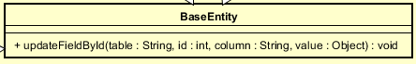

**Attribute**:

None

**Operation**:

|  |  |  |  |
| --- | --- | --- | --- |
| # | Name | Return type | Description (purpose) |
| 1 | updateFieldById | void | Update column any table in database with primary key id by value |

**Method**: None

**State**: None

***4.4.3.27 Class “Bike”***

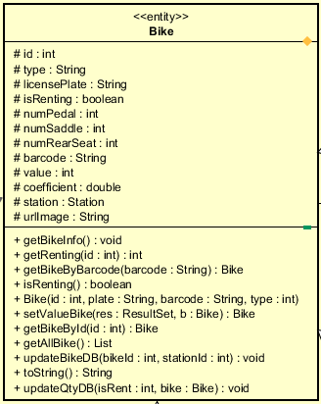

**Attribute**

|  |  |  |  |  |
| --- | --- | --- | --- | --- |
| # | Name | Data type | Default value | Description |
| 1 | numSaddle | int | NULL | Number saddle of the bike |
| 2 | numPedal | int | NULL | Number pedal of the bike |
| 3 | numRearSeat | Int | NULL | Number rear seat of the bike |
| 4 | licensePlate | String | NULL | Represent license plate of the bike |
| 5 | value | int | NULL | Represent value of the bike |
| 6 | barcode | String | NULL | Represent barcode of the bike |
| 7 | type | String | NULL | Represent type of the bike |
| 8 | station | Station | NULL | Represent bike in which station |
| 9 | Coefficient | double | NULL | The coefficient uses when calculate deposit |
| 10 | urlImage | String | NULL | The path to the bike image |
| 11 | isRenting | boolean | NULL | Check if the bike is being rented or not |
| 12 | Id | Int | NULL | The id of the bike in database |

**Operation**

|  |  |  |  |
| --- | --- | --- | --- |
| # | Name | Return type | Description (purpose) |
| 1 | getBikeInfo | void | Get bike information for display |
| 2 | getRenting | int | Check the bike with corresponding id is being rented or not |
| 3 | Bike | void | Constructor |
| 4 | getter | void | Get all attribute in acronym |
| 5 | setter | void | Set value for each attribute in acronym |
| 6 | getBikeByBarcode | Bike | Get a bike using its barcode |
| 7 | isRenting | Boolean | Check if a bike is currently being rented |
| 8 | setValueBikes | Bike | Set a bike info base on a result set |
| 9 | getBikeByID | Bike | Get a bike by using its id |
| 10 | getAllBike | List[bike] | Get all the bike in database |
| 11 | updateBikeDB | Void | Change the station of a bike in database |
| 12 | toString | String | Convert a bike object to string |
| 13 | updateQtyDB | Void | update station and bike when a bike is returned/rented |

Method: none

State:

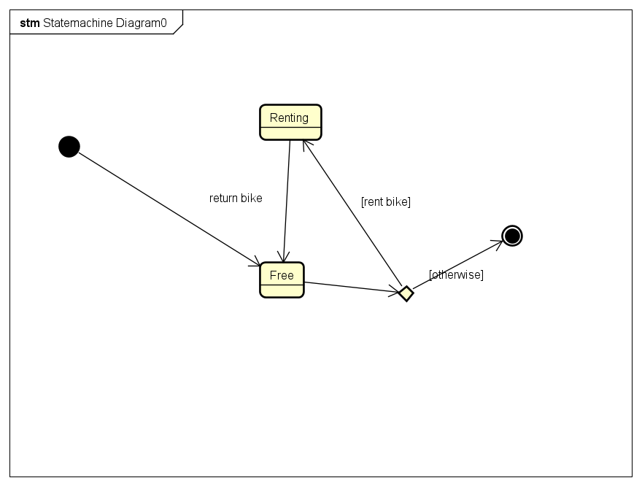

***4.4.3.28 Class “Standard Bike”***

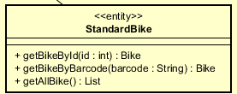

**Attribute**

**Operation:**  Inherit from bike entity and override

|  |  |  |  |
| --- | --- | --- | --- |
| # | Name | Return type | Description (purpose) |
| 1 | getBikeById | Bike | Get a standard bike by its id |
| 2 | getBikeByBarcode | Bike | Get a standard bike by its barcode |
| 3 | getAllBike | List[Bike] | Get all standard bike |

**Method:** none

**State:** none

***4.4.3.29 Class “Standard Electric Bike”***

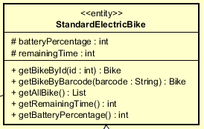

**Attribute**

|  |  |  |  |  |
| --- | --- | --- | --- | --- |
| # | Name | Data type | Default value | Description |
| 1 | batteryPercentage | int | NULL | The battery percentage of the electric bike |
| 2 | remaningTime | int | NULL | The remaining time of the electric bike |

**Operation:**

* **Inherit from bike entity and override**

|  |  |  |  |
| --- | --- | --- | --- |
| # | Name | Return type | Description (purpose) |
| 1 | getBikeById | Bike | Get a standard electric bike by its id |
| 2 | getBikeByBarcode | Bike | Get a standard electric bike by its barcode |
| 3 | getAllBike | List[Bike] | Get all standard electric bike |
| 4 | Getter/setter | Void | Get/set attribute in acronym |

**Method:** none

**State:** none

***4.4.3.30 Class “Twin Bike”***

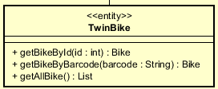

**Attribute**

**Operation:**

* **Inherit from bike entity and override**

|  |  |  |  |
| --- | --- | --- | --- |
| # | Name | Return type | Description (purpose) |
| 1 | getBikeById | Bike | Get a twin bike by its id |
| 2 | getBikeByBarcode | Bike | Get a twin bike by its barcode |
| 3 | getAllBike | List[Bike] | Get all twin bike |

**Method:** none

**State:** none

***4.4.3.31 Class “Twin Electric Bike”***

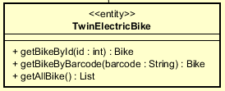

**Attribute**

**Operation:**

* **Inherit from standard electric bike entity and override**

|  |  |  |  |
| --- | --- | --- | --- |
| # | Name | Return type | Description (purpose) |
| 1 | getBikeById | Bike | Get a twin electric bike by its id |
| 2 | getBikeByBarcode | Bike | Get a twin electric bike by its barcode |
| 3 | getAllBike | List[Bike] | Get all twin electric bike |

**Method:** none

**State:** none

***4.4.3.32 Class “EcoBikeRental”***

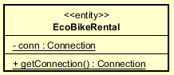

***Attribute***

|  |  |  |  |  |
| --- | --- | --- | --- | --- |
| # | Name | Data type | Default value | Description |
| 1 | Conn | Connection | NULL | Connection to the remote database |

***Operation***

|  |  |  |  |
| --- | --- | --- | --- |
| # | Name | Return type | Description (purpose) |
| 1 | getConnetion | Connection | Connect to the remote database |

***Method:*** None

***State:*** None

***4.4.3.33 Class “Invoice”***

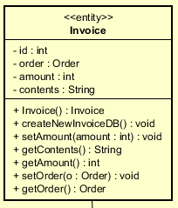

***Attribute***

|  |  |  |  |  |
| --- | --- | --- | --- | --- |
| # | Name | Data type | Default value | Description |
| 1 | Id | Int | NULL | The id of the invoice |
| 2 | order | Order | NULL | The order that was used for this invoice |
| 3 | Amount | Int | NULL | The amount the user has to pay/is refunded to. |
| 4 | content | String | NULL | The details of the invoice |

***Operation***

|  |  |  |  |
| --- | --- | --- | --- |
| # | Name | Return type | Description (purpose) |
| 1 | Invoice |  | Constructor |
| 2 | newInvoiceDB | void | Save the invoice to the database, after successful transaction |
| 3 | Getter/setter | void | Get/set attribute in acronym |

***Method:*** None

***State:*** None

***4.4.3.34 Class “Order”***

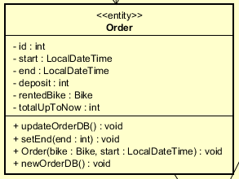

***Attribute***

|  |  |  |  |  |
| --- | --- | --- | --- | --- |
| # | Name | Data type | Default value | Description |
| 1 | Id | Int | NULL | The id of the order |
| 2 | start | LocalDateTime | NULL | The time when user starts renting bike |
| 3 | End | LocalDateTime | NULL | The time when user returns bike |
| 4 | Deposit | Int | NULL | The amount of deposit when rent bike |
| 5 | rentedBike | Bike | NULL | The bike which is being rented |
| 6 | totalUpToNow | Int | NULL | Total renting amount (not include deposit) |

***Operation***

|  |  |  |  |
| --- | --- | --- | --- |
| # | Name | Return type | Description (purpose) |
| 1 | Order |  | Constructor |
| 2 | newOrderDB | void | Insert new order to database, after renting bike successfully |
| 3 | updateOrderDB | void | Update the order in the database, after returning bike successfully |
| 4 | Getter/setter | void | Get/set attribute in acronym |

***Method:*** None

***State:*** None

***4.4.3.35 Class “Station”***

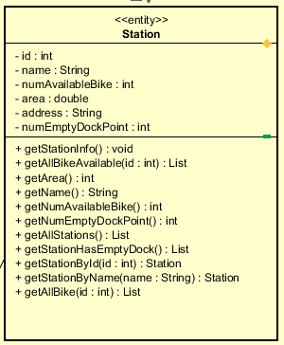

***Attribute***

|  |  |  |  |  |
| --- | --- | --- | --- | --- |
| # | Name | Data type | Default value | Description |
| 1 | Id | Int | NULL | The id of the station |
| 2 | name | String | NULL | The name of the station |
| 3 | numAvailableBike | Int | NULL | Number of available bike in the station |
| 4 | Area | Double | NULL | Area of the station |
| 5 | Address | String | NULL | Address of the station |
| 6 | numEmptyDockPoint | Int | NULL | Number of empty dock point in station |

***Operation***

|  |  |  |  |
| --- | --- | --- | --- |
| # | Name | Return type | Description (purpose) |
| 1 | Station |  | Constructor |
| 2 | getAllBikeAvaiable | List[Bike] | Get all bike in a station with given station id, and the bike is currently not being rented |
| 3 | getAllStation | List[Station] | Get all the station in database |
| 4 | Getter/setter | void | Get/set attribute in acronym |
| 5 | getStationById | Station | Get a station with its id |
| 6 | getStationByName | Station | Get a station by its name |
| 7 | getAllBike | List[Bike] | Get all bike in a station with given station id |
| 8 | getStationHasEmptyDock | List[Station] | Get all stations which have empty dock for returning bike |

***Method:*** None

***State:*** None

***4.4.3.36 Class “Card”***

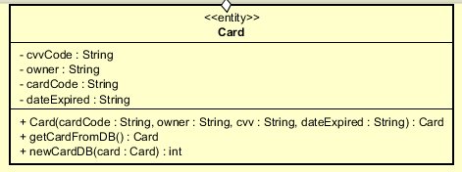

***Attribute***

|  |  |  |  |  |
| --- | --- | --- | --- | --- |
| # | Name | Data type | Default value | Description |
| 1 | owner | String | NULL | Name of the owner of the credit card |
| 2 | cardCode | String | NULL | code of the credit card |
| 3 | cvvCode | String | NULL | Security code of the credit card |
| 4 | dateExpired | String | NULL | The expiration date of the card, in form MMYY |

***Operation***

|  |  |  |  |
| --- | --- | --- | --- |
| # | Name | Return type | Description (purpose) |
| 1 | Card |  | Constructor |
| 2 | newCardDB | int | Save the card in the database if this is a new card. Get the id of the corresponding card in database. |
| 3 | getCardFromDB | Card | Get the card from database |
| 4 | Getter/setter | void | Get/set attribute in acronym |

***Method:*** None

***State:*** None

***4.4.3.37 Class “TransactionInfo”***

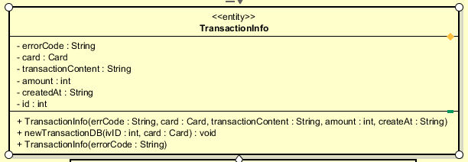

***Attribute***

|  |  |  |  |  |
| --- | --- | --- | --- | --- |
| # | Name | Data type | Default value | Description |
| 1 | card | Card | NULL | Represent the card used for payment |
| 2 | amount | int | NULL | Represent total amount of the transaction |
| 3 | TransactionContent | String | NULL | Represent content of transaction |
| 4 | createdAt | String | NULL | The time when the transaction was created |
| 5 | Id | Int | NULL | The id of the transaction |
| 6 | errorCode | String | NULL | The error code represents the state of the transaction |

***Operation***

|  |  |  |  |
| --- | --- | --- | --- |
| # | Name | Return type | Description (purpose) |
| 1 | TransactionInfo |  | Constructor |
| 2 | newTransactionDB | void | Save the successful transaction to database, and the card used for the transaction |
| 3 | Getter/setter | void | Get/set attribute in acronym |

***Method:*** None

***State:*** None

***4.4.3.38 Class “PaymentScreenHandler”***

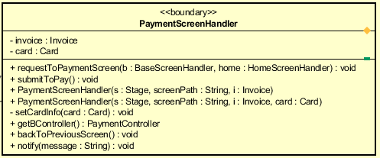

**Attribute**

|  |  |  |  |  |
| --- | --- | --- | --- | --- |
| # | Name | Data type | Default value | Description |
| 1 | invoice | Invoice | NULL | The invoice created for this payment |
| 2 | card | Card | NULL | The card used for this payment |

**Operation**

|  |  |  |  |
| --- | --- | --- | --- |
| # | Name | Return type | Description (purpose) |
| 1 | requestToPaymentScreen | Void | Request to move to this screen |
| 2 | submiToPay | Void | Handle the process when user click submit button |
| 3 | PaymentScreenHandler |  | constructor |
| 4 | setCardInfo | void | Set the card info to display on this screen |
| 5 | getBController | PaymentController | Set the controller for this screen |
| 6 | backToPreviousScreen | Void | Back to previous screen |
| 7 | notify | Void | Display error on screen |

**Method:** none

**State:** none

***4.4.3.39 Class “TransactionErrorScreenHandler”***

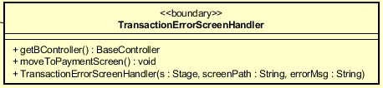

**Attribute**

**Operation**

|  |  |  |  |
| --- | --- | --- | --- |
| # | Name | Return type | Description (purpose) |
| 1 | getBController | BaseController | Set controller for this screen |
| 2 | moveToPaymentScreen | Void | Move back to payment screen |
| 3 | TransactionErrorScreenHandler |  | Constructor |

**Method:** none

**State:** none

***4.4.3.40 Class “ResultScreenHandler”***

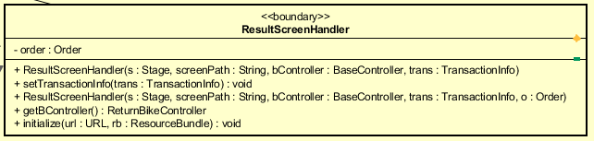

**Attribute**

|  |  |  |  |  |
| --- | --- | --- | --- | --- |
| # | Name | Data type | Default value | Description |
| 1 | order | Order | NULL | The order used for the rent/return payment process |

**Operation**

|  |  |  |  |
| --- | --- | --- | --- |
| # | Name | Return type | Description (purpose) |
| 1 | ResultScreenHandler |  | Constructor |
| 2 | setTransactionInfo | Void | Set all the info displayed on the screen |
| 3 | getBController | ReturnBikeController | Set the controller for this screen |
| 4 | initialize | void | initialize the content of the screen |

**Method:** none

**State:** none

# Design Considerations

## Goals and Guidelines

**Goals:**

* Bring a good looking and good experience for users
* The response time for the system is 1 second at normal and 2 seconds during a peak load

**Guidelines**

* Observe java convention in coding, OOP principles
* Avoid hash code
* Explain code, write java doc for maintenance

## Architectural Strategies

Our design decisions focus on reusing components, unified system following

+ Programing Language: java

+ Database: MySQL

+ Unified on error detection and recovery

We always toward save memory and spaces, also speed up response time and nice looking. In the future, we plan to extend software: have site for admin to add, delete bike, statistics, business strategies. These targets make us concentrate totally on architectural design.

## Coupling and Cohesion

In our software design, we detect that there are some components have Control Coupling and Communicational Cohesion problems.

We are trying our best to resolve these problems, decrease Coupling level and increase Cohesion level. However, due to lack of time, we might not be able to fix this before announced deadline.

We will resolve these as soon as possible.

## Design Principles

We design simple classes that means a class should have only one job, one responsibility. Object or entities are open for extension but close for modification. We also use interfaces, abstract classes. We put all class with same properties into one package to manage easily. Therefore, we can reuse source code, adapt any changing requirements.

## Design Patterns

We don’t use any design patterns.